Historical overview of the wild buffalo and their status today in Yellowstone

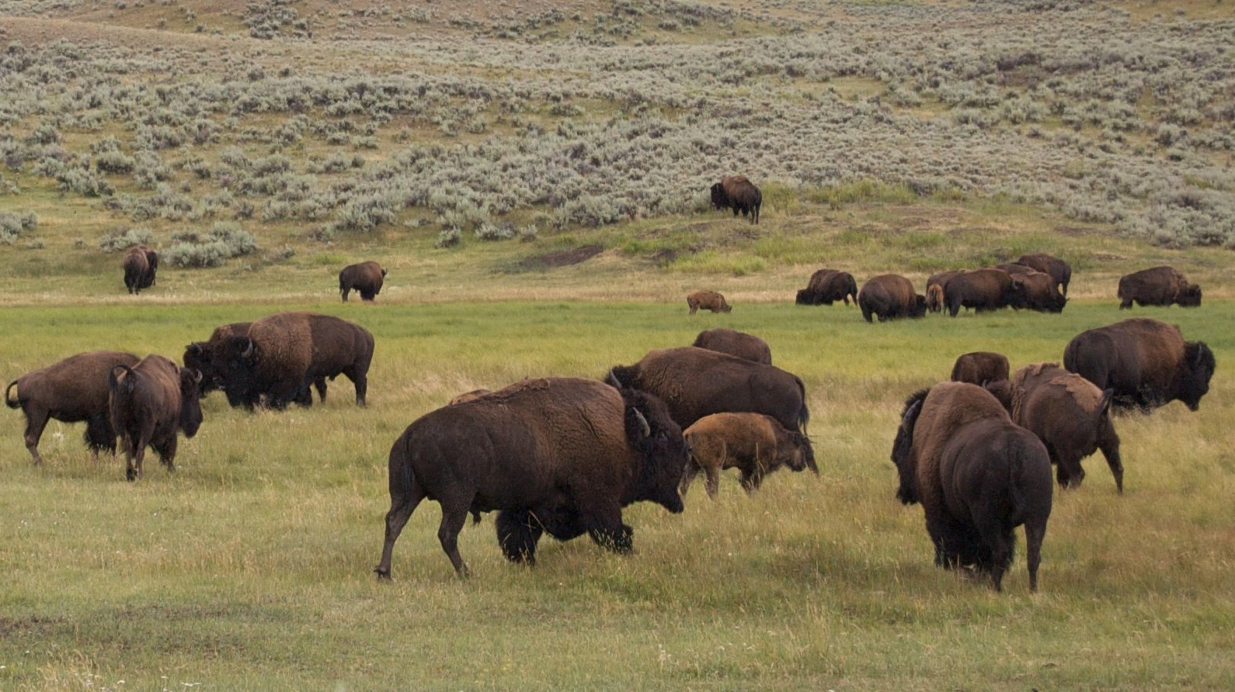
Darrell Geist photo. Buffalo rutting territory, Hayden valley.

"Let it be known that Yellowstone territory; the habitat of the last wild Buffalo Nation - is sacred ground, it has been a SACRED SITE for the First Nation's people, and for all humanity who hold deep respect for all Creation.”
Lakota Chief Arvol Looking Horse, 19th Generation Keeper of the White Buffalo Calf Pipe

Since time immemorial, the American bison or buffalo has been central to the identity, culture, spirituality, traditional teachings and well being of North America’s indigenous peoples (Looking Horse 2008).

Traditional cultures adopted buffalo teachings ‘Tiospaye’ within their own social structures of nurturing strong family bonds, showing a willingness to look after one another in an extended group, sharing the hardships in breaking trail to find food, fending for the lesser among your band, following their elders lead, traits that served the wild species well and the buffalo cultures that evolved with them.

“It takes a herd to raise a good buffalo calf,” says Rosalie Little Thunder, Sicangu Lakota, noting how her Tribe adopted a “sophisticated matriarchal system” from the buffalo as a model for social order.
Traditional cultures are keen observers and have long understood the keystone roles wild nomadic buffalo have in providing for native plant, fish, bird, insect and wildlife diversity, healthy grasslands, and clean watersheds, ecological contributions often overlooked and under appreciated by wildlife and public lands managers today.

Buffalo, North America’s largest terrestrial mammal and historically its most numerous mammal that left behind 100 million wallows, are architects of their environment shaping their world through shared behaviors in migratory herds across diverse habitats ranging from the Chihuahuan desert to northern grasslands: hooves tilling the soil, opening the earth to replenish fresh water aquifers, horns and hides gouging and rubbing trees on the edges of forests, keeping grasslands open for grassland dependent species, wallowing to create catch basins in the spring that become fire and drought resistant patches of earth in the summer (Fallon 2009; Knapp 1999).
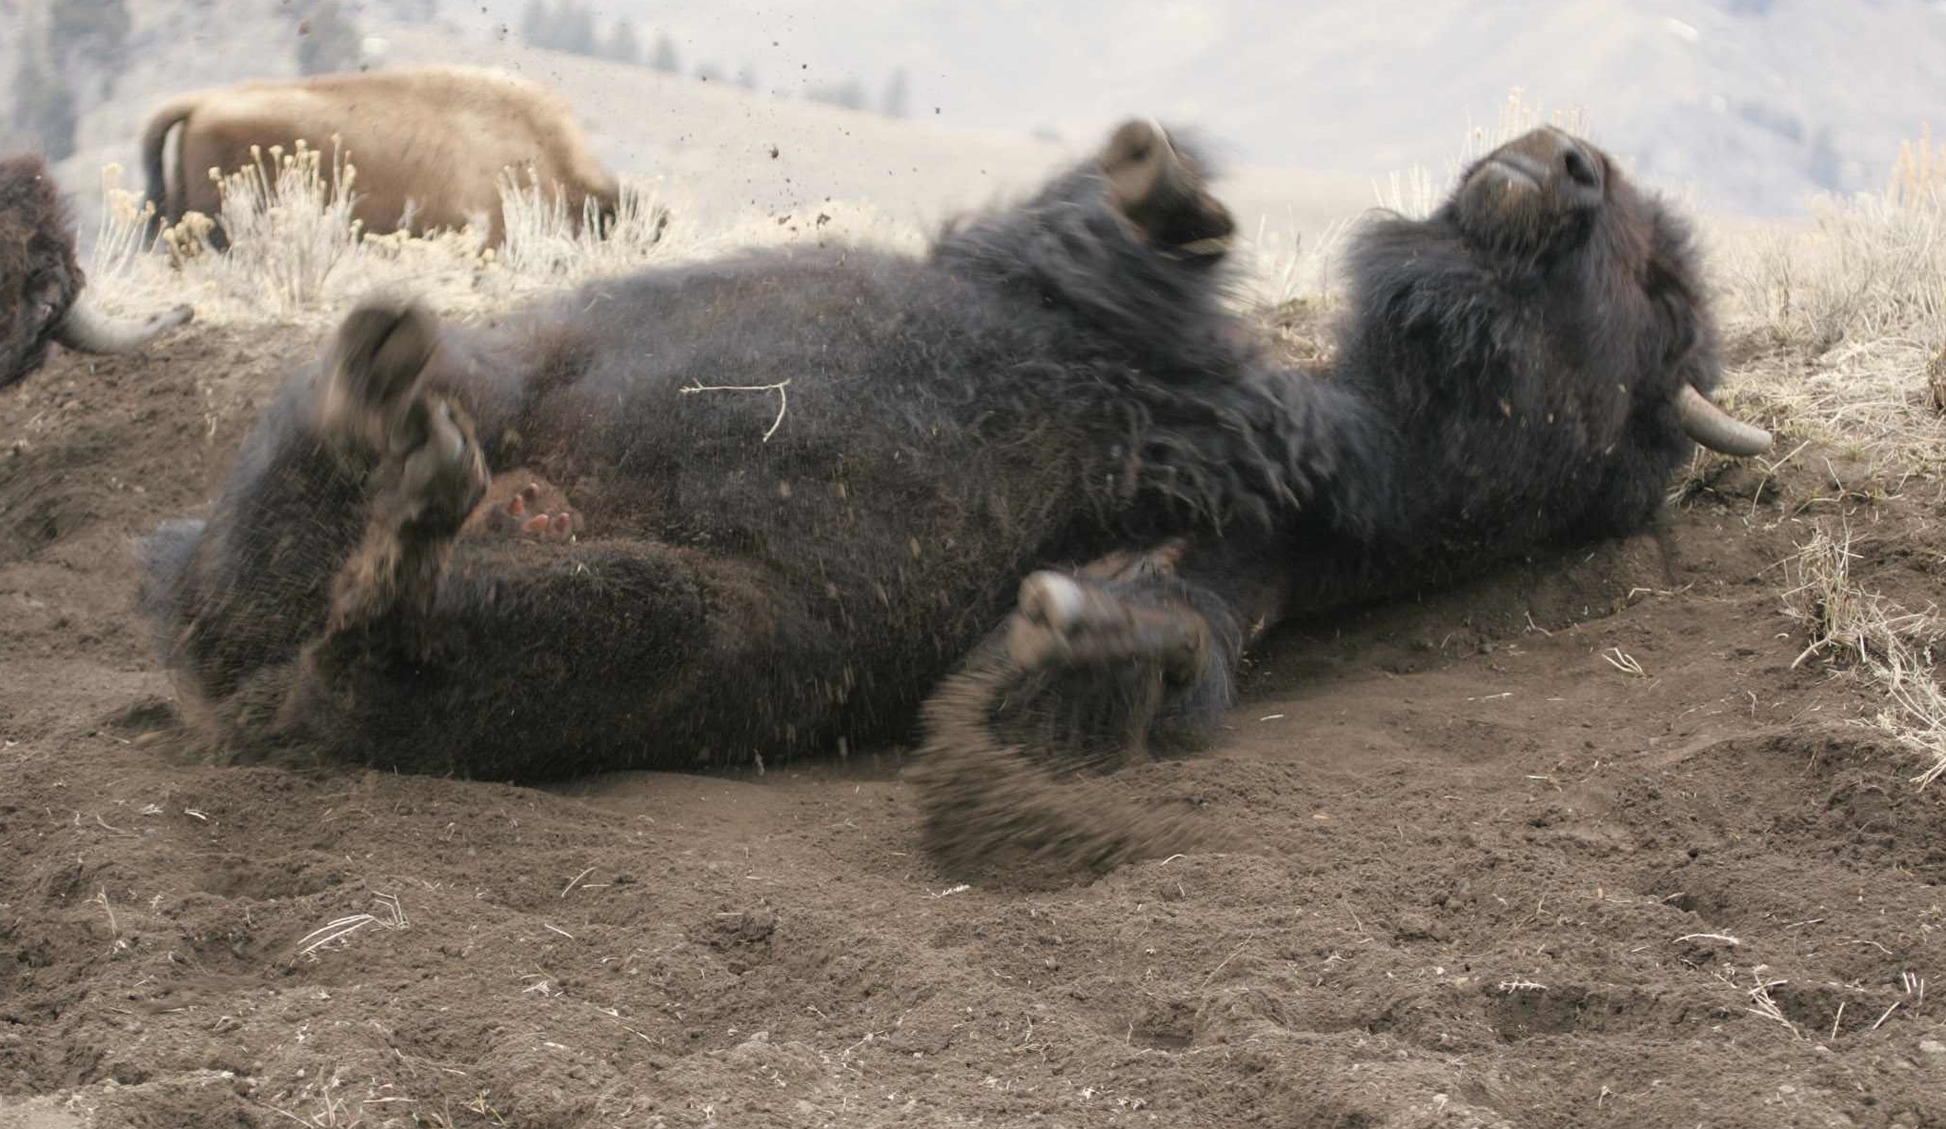
Jim Peaco photo. Buffalo wallowing, Little America Flats.

Buffalo on the move clipping grass, stimulating root growth; chips scattered across meadows tipped by bears grubbing for insects and earthworms, spreading plant nutrients and grass seeds; wallows creating ephemeral spring pools used by rare toads, frogs and snakes; migrating to fire burned habitats to recover grasses, spreading nutrient-rich urine; heads and horns plowing through deep snow making forage accessible to other native grass eaters; wallowing, creating more drought, fire resistant and diverse grasslands; native birds hitching a ride on their humps to eat insects and seeds dispersed by their nomadic movements, grabbing tufts of buffalo fur for their nests; preyed upon by grizzly bear and gray wolf, eagles, ravens, magpies, coyotes, red foxes sharing in the food source; carcasses returning, replenishing the earth.

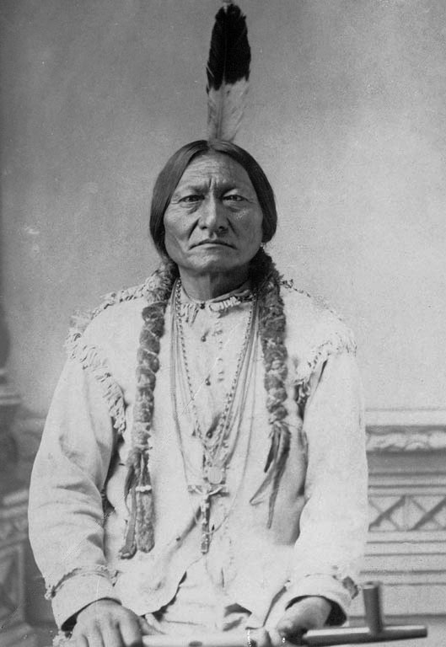
Buffalo’s “vibration of their massive movements stimulated underground water levels and generated the energy to draw the thunderclouds to nourish the Earth,” according to Little Thunder. “Tatanka are one of the species held sacred by Indigenous Peoples for their ability to support so many other species, to truly manage the Earth.”

Her elder and mentor Keith Sydney encouraged Little Thunder’s “continuing commitment and reciprocal responsibility” to buffalo. “The buffalo are an integral part of our culture, but a deeper concern is for the Earth in the absence of its caretaker.”
Tatanka-I-Yotanka

The near extermination of the wild American bison
"A cold wind blew across the prairie when the last buffalo fell-a death-wind for my people." Sitting Bull, Hunkpapa Lakota

To recount the story of the buffalo is to recount the story of buffalo cultures that emerged and evolved in their presence for thousands of years and suffered the decimation of the buffalo during a violent, expansionist epoch in American history.

With the complicity of U.S. government authorities and the frontier army (Smits 1994), the American bison was systematically slaughtered to near-extinction in the 19th century (Hornaday 1889).

U.S. military campaign strategy to impoverish the buffalo from the Great Plains and forcibly restrict nomadic Indian tribes to reservations, in tandem with commercial market exploitation (Isenberg 2000; Suagee 1999), created the conditions for extirpation of buffalo from nearly all of their original range – one-third of North America’s land mass spanning more than twenty unique ecosystems across two billion acres of habitat (Sanderson 2008).

Prized for their strength and versatility, buffalo hides powered the industrial revolution’s conveyors and belts used in factory mass production, in turn, commercial markets fully exploited the wholesale slaughter of buffalo:

“Eastern cities and the markets of Europe, sold on the romance of the buffalo robe, hastened the buffalo’s demise. Buffalo coats, softer than lamb’s wool, were warm and stylishly wild—the frontier brought to the salon. The hides, transformed by new methods of tanning, became belts, bags, the uppers for the most fashionable boots and shoes; the preferred leather for carriage tops, sleighs, and hearses; the prize material for the drive belts in the factories of the Industrial Revolution; and armor and jackets for the English, French, and German armies, which were resupplying in the wake of Bismarck’s wars.³ The tongues, fresh or smoked, were considered a delicacy by the rich and brought twenty-five cents apiece; the hams went for three cents a pound at the rail depots; the horns and hooves became buttons, knife handles, and glue; and the bones, used as fertilizer or as a whitener for sugar, sold for eight dollars a ton.”
Christopher Ketcham, Harper’s Magazine
The arrival of Spanish horses, Euro-Americans with repeating firearms, federal land grants and expansion of the railroads, emergence of a market-driven economy and commercial hunting trade devastated wild buffalo (Isenberg 2000; Flores 1991; Schullery and Whittlesey 2006) and reduced their numbers from as many 30 to 60 million to a few hundred by the end of the 19th century (Boyd and Gates 2006).

Ketcham writes between “1870 and 1880, at least 10 million buffalo, and possibly as many as 20 million, were killed. Two hundred thousand hides were sold in Fort Worth in a single day.”
Climatic change including droughts, flooding, blizzards and the introduction of non-native diseases and European and African livestock contributed to the wild buffalo’s demise across their historic range (Isenberg 2000; Flores 1991).

Ketcham writes thereafter “the northern plains would be cattle country. Between 1866 and 1884, at least 5 million longhorns were driven north out of Texas. The number of cattle in Wyoming rose from 90,000 in 1874 to 500,000 by 1880; and by 1883 in Montana, where ten years earlier there were practically no cows, half a million now grazed on grasses untouched by their rivals. ‘For every single buffalo that roamed the Plains in 1871,’ wrote Colonel Dodge, ‘there are in 1881 not less than two, and more probably four or five, of the descendants of the longhorned cattle of Texas.’”

Ketcham’s research finds the ascent of cattle baron’s monopoly control over western resources was made possible by east coast and British banks and investment companies using front companies and “stockmen’s associations” to grab land often through fraud and graft.
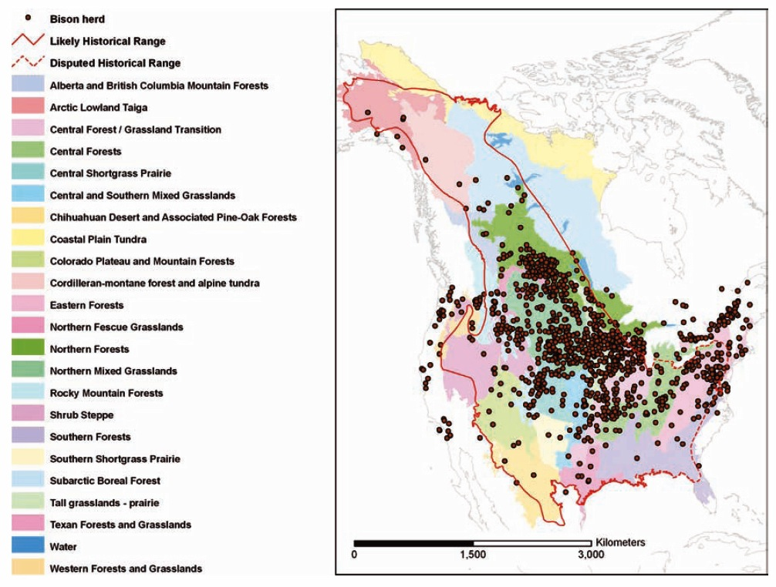
“Distribution of a sample of existing American bison herds across the historical range (and beyond) in North America. The size of the dots overestimates the actual area occupied. Best estimates are that bison currently occupy <1% of their circa 1500 historical range (modified from Hall & Kelson 1959), shown in red. Major habitat types are indicated by colored areas in the background.” Eric Sanderson, The Ecological Future of the North American Bison

It was a Spaniard, Coronado, who introduced cattle into the western range in 1540 soon followed by missionaries extolling “the virtues of pastoralism” to indigenous peoples inhabiting the southwest (Fleischner 2009).

Western cowboy and cattle ranch culture is an imitation of Mexican vaqueros, and livestock grazing is now the “most ubiquitous land use in the western United States,” writes Fleischner.

After creation of Yellowstone National Park in 1872, weak and ineffectual wildlife protection laws left the few wild buffalo remaining vulnerable to poachers in pursuit of a vanishing chance to kill the last buffalo (Cope 1885; Meagher 1973).

In 1874, President Ulysses S. Grant pocket-vetoed a bill passed by the U.S. Congress to protect buffalo from being unlawfully hunted by non-Indians (Smits 1994).

Amidst a “tense climate” in Indian Country (Nabokov and Loendorf 1999) the “last of Yellowstone's human inhabitant's, a band of Sheep Eaters, were removed in 1879.” (Kantor 2007)

“For tribe after tribe, this suppression of traditional ties to their old Yellowstone hunting and traveling grounds precipitated a century-long period of broken connections,” traditions that were not renewed in their absence (Nabokov and Loendorf 1999).
Free roaming migrations of wild buffalo came to an end just as it did for the nomadic peoples who followed them.
By the turn of the 20th century, only 23 wild buffalo remained in the United States taking refuge in Yellowstone's remote Pelican valley under armed patrols by the U.S. Army (Meagher 1973).
The near extinction of buffalo in Yellowstone was averted by reintroduction of buffalo in the early 1900s from the Confederated Salish and Kootenai Tribes, Pablo, Allard, Walking Coyote, and Goodnight families (Wood 2000; Boyd 2003).
For 60 years reintroduced buffalo were intensively managed through livestock husbandry and removal of “surplus” buffalo until the Park adopted natural regulation in 1969. Natural regulation gave way to “boundary control” and a state hunt initiated than abandoned by Montana due to nationwide public outcry. A series of interim plans proposed by Yellowstone National Park and the state of Montana in the 1990s to prevent buffalo migration beyond Park boundaries to their traditional winter range, led to the slaughter of 1,083 buffalo in 1996-1997 when thick ice encased local forage (White 2011). Hundreds of buffalo succumbed to winterkill and by spring over half the population was killed.
Since 1985, the state of Montana and Yellowstone National Park have slaughtered over 6,800 wild buffalo migrating into Gardiner and Hebgen Lake basins.
Nearly all buffalo today are descended from 76 to 84 individuals scattered in five bands and 23 wild buffalo in Yellowstone (Halbert 2003; Hedrick 2009). This severe genetic bottleneck left twelve bloodlines that founded all remaining buffalo populations.

Beginning over 120 years ago, four bloodlines were artificially crossed with cattle by ranchers to commercially exploit survival attributes of buffalo. Cattle ancestry in buffalo is now widespread (Hedrick 2010) and Yellowstone is considered the last American population to retain their identity as wild migratory plains bison (U.S. Dept. of the Interior FOIA 2010).

A fecal DNA study by Gardipee (2007) found the make-up of Yellowstone’s buffalo population is comprised of “genetically distinct breeding groups” driven by maternal fidelity to rutting territories in the Northern Range and Central Interior.

Dr. Mary Meagher, Yellowstone National Park's bison biologist for more than 30 years, believes that 10,000 years ago at the end of the last Ice Age glacial retreat opened up range for buffalo migrating from surrounding river valleys that followed plant green up to the Yellowstone plateau (Gates 2005). Yellowstone's unique geothermal features opened winter range for buffalo to occupy habitat year round (Meagher 1973).
Archeological investigations and historical evidence indicate large numbers of migratory buffalo populations occupied the Yellowstone ecosystem (Cannon 2001; Schullery and Whittlesey 2006) and that climatic changes played an important role in buffalo distribution, seasonal migration and abundance (Cannon 1997).

Brucellosis introduced to Yellowstone buffalo and elk by cattle
“Brucellosis is a zoonotic disease; in humans, it is manifested as a febrile, systemic disease, often characterized by an undulating body temperature…The hallmark sign in cattle, bison, and elk is abortion or birth of nonviable calves…Today, some 30-40% of bison in YNP test seropositive for B. abortus; 1-2% of non-feeding-ground elk are seropositive. Elk at the feeding grounds have a much higher rate—about 37%—because dense concentrations of animals create conditions favorable to disease transmission…Human brucellosis is uncommon today in North America because of efforts to eradicate brucellosis in cattle and the use of sanitary procedures (such as pasteurization) in milk processing…[In 1934] the U.S. Department of Agriculture (USDA) established a national brucellosis eradication effort—which implemented standards for testing, quarantine, and elimination—that remains in place today. Since 1934, an estimated $3.5 billion in federal, state, and private funds has been spent on brucellosis eradication in domestic livestock.” Norman F. Cheville, Brucellosis in the Greater Yellowstone Area

Brucellosis was originally introduced to Yellowstone’s wild buffalo and elk populations by domestic cattle before 1917 (Cheville 1998; Meagher and Meyer 1994).

Buffalo calves captured from the wild were “mothered with domestic bovine cows” and pastured with cattle that were brought into Yellowstone to feed Park tourists (Meagher and Meyer 1994; Meagher 1973).

The risk of brucellosis transmission from wild buffalo to cattle is small (Cheville et al. 1998) and there has been no documented case of such an event. The first quantified study by Kilpatrick (2009) examining the risk of brucellosis transmission from Yellowstone buffalo to domestic cattle found that “transmission of brucellosis from bison to cattle even under a 'no plan' (no management of bison) strategy is likely to be a relatively rare event.”

A study of the environmental persistence of brucella abortus by Keith Aune concluded, “natural environmental conditions and scavenging conspire to rapidly kill or remove brucella from the environment.” By June 15, any brucella shed by buffalo is destroyed.

Veterinary Services, a branch of U.S. Dept. of Agriculture’s Animal and Plant Health Inspection Service, has adopted and Montana has accepted new rules governing brucellosis removing the threat of whole herd cattle slaughter, state sanctions against Montana cattle, and loss of Montana’s brucellosis free status. Montana now requires ranchers to test cattle in Designated Surveillance Areas as approved by the State Veterinarian. Montana taxpayers are paying for half the rancher’s vaccination costs.

The new rules have resulted in “an annual economic benefit of $5.5 to $11.5 million to livestock producers statewide,” according to the Montana Dept. of Livestock. (Online: http://liv.mt.gov/liv/news/2011/20110304.asp)

Recent investigations by Beja-Pereira (2009) of brucellosis transmission to cattle in the Yellowstone ecosystem indicate that elk are the suspect source of infections in Montana, Wyoming and Idaho.

Despite these facts, state and federal agents have spent tens of millions of taxpayer dollars and killed thousands of wild buffalo that pose no risk to cattle (GAO 2008).
Status of buffalo in Yellowstone today
"Bison were a keystone species of the prairie ecosystem; significantly affecting the way the prairie grassland ecosystem evolved and playing an important role in maintaining it. Wild bison remain ecologically extinct in Montana. The State of Montana Department of Livestock has prevented the natural dispersal of wild bison into Montana from Yellowstone National Park because of disease issues while no attempts are underway to restore the species outside of this controversial region. Current management of private, state and Federal bison herds is leading towards domestication of bison that threatens their wild character and limits important natural selection processes." The Wildlife Society, Montana Chapter Position Statement on Wild Bison in Montana

The on-going framework for managing buffalo in Yellowstone is the Interagency Bison Management Plan, a result of litigation by the state of Montana against the U.S. Department of the Interior and a court ordered settlement (Lovell 2011). Since its inception in 2000, over 3,200 wild buffalo have been destroyed in the Yellowstone ecosystem, mainly on public lands in America's flagship Yellowstone National Park by the National Park Service and on the Gallatin National Forest by the Montana Department of Livestock.

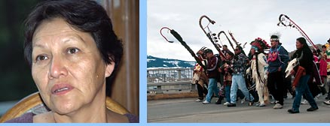
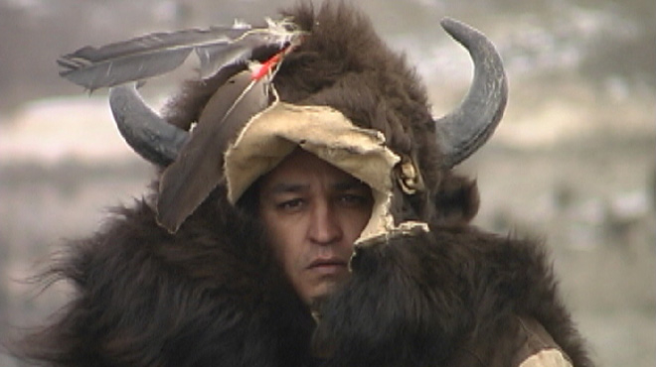
PBS, Buffalo Wars photo.
During the winter of 1998-1999, Rosalie Little Thunder, Sicangu Lakota, organized a 500-mile Walk for the Buffalo from Rapid City, South Dakota to the gateway arches of Yellowstone National Park in Gardiner, Montana. Thirty American Indian tribes walked to represent their cultural identity and responsibility to buffalo, offering prayers and personal sacrifices, and calling for an end to the war against the last wild American buffalo.

In mid-2000 the state of Montana began to recognize treaty rights to hunt in aboriginal territories and the “going to buffalo” tribes (Farr 2003) have begun to make long distance treks to hunt buffalo again.
During the winter of 2006-2007 members of the Confederated Salish and Kootenai Tribes hunted buffalo on open and unclaimed federal lands under an 1855 treaty negotiated with Isaac I. Stevens, Governor of Washington Territory (Treaty of Hellgate, July 16, 1855). Montana also recognized an 1855 treaty between the United States and the Nez Perce to hunt buffalo on the Gallatin National Forest (Harris 2008).
In 2011 members of the Confederated Tribes of the Umatilla Indian Reservation Cayuse, Walla Walla and Umatilla, returned to their traditional aboriginal territory in Yellowstone to hunt buffalo on National Forest lands.
Treaty rights to hunt stem from a 5-to-4 decision by the U.S. Supreme Court in 1999 recognizing “usufructuary rights” of the Mille Lacs Band of the Chippewa to traditional food sources on ceded land under an 1837 Treaty (Harris 2008).
The state of Montana also reinstated a buffalo hunt in 2004 for “disease control” purposes subject to Dept. of Livestock approval (MCA 87-2-730).
The Interagency Bison Management Plan’s stated purpose is to “maintain a wild, free ranging population of bison and address the risk of brucellosis transmission to protect the economic interest and viability of the livestock industry in the state of Montana,” and is comprised of the National Park Service, U.S. Forest Service, U.S. Dept. of Agriculture Animal and Plant Health Inspection Service, Montana Dept. of Livestock and Montana Fish, Wildlife & Parks (online: ibmp.info).
Numerous buffalo have died or were euthanized as a result of injuries suffered while held in Yellowstone National Park’s trap at Stephens Creek. Buffalo have aborted their calves in captivity. Calves have been born in traps (Yellowstone National Park 2008).
Only recently has the federal and state agencies agreed to Tribal delegate representation from the Nez Perce, Confederated Salish and Kootenai Tribes, and InterTribal Buffalo Council, a federally recognized Tribal business cooperative of 57 member Tribes dedicated to the restoration of buffalo in a manner compatible with traditional spiritual and cultural beliefs and practices.
A U.S. Government Accountability Office report documented the agency’s lack of accountability to the American people and Congress, lack of progressive measures towards goal achievement, lack of scientific review addressing assumptions and unknowns to improve decisions in the field, agency failure to adapt new science when it emerges, significant delays in progressing to the next step in a 3-step plan, millions of taxpayer dollars spent on land deals that have not benefited wild buffalo roaming freely in their native range, the fact that buffalo are unnecessarily killed (GAO 2008) or have lingered in quarantine because the agencies behind it have made it politically onerous and financially costly to take them (Magnon and Fox 2011).
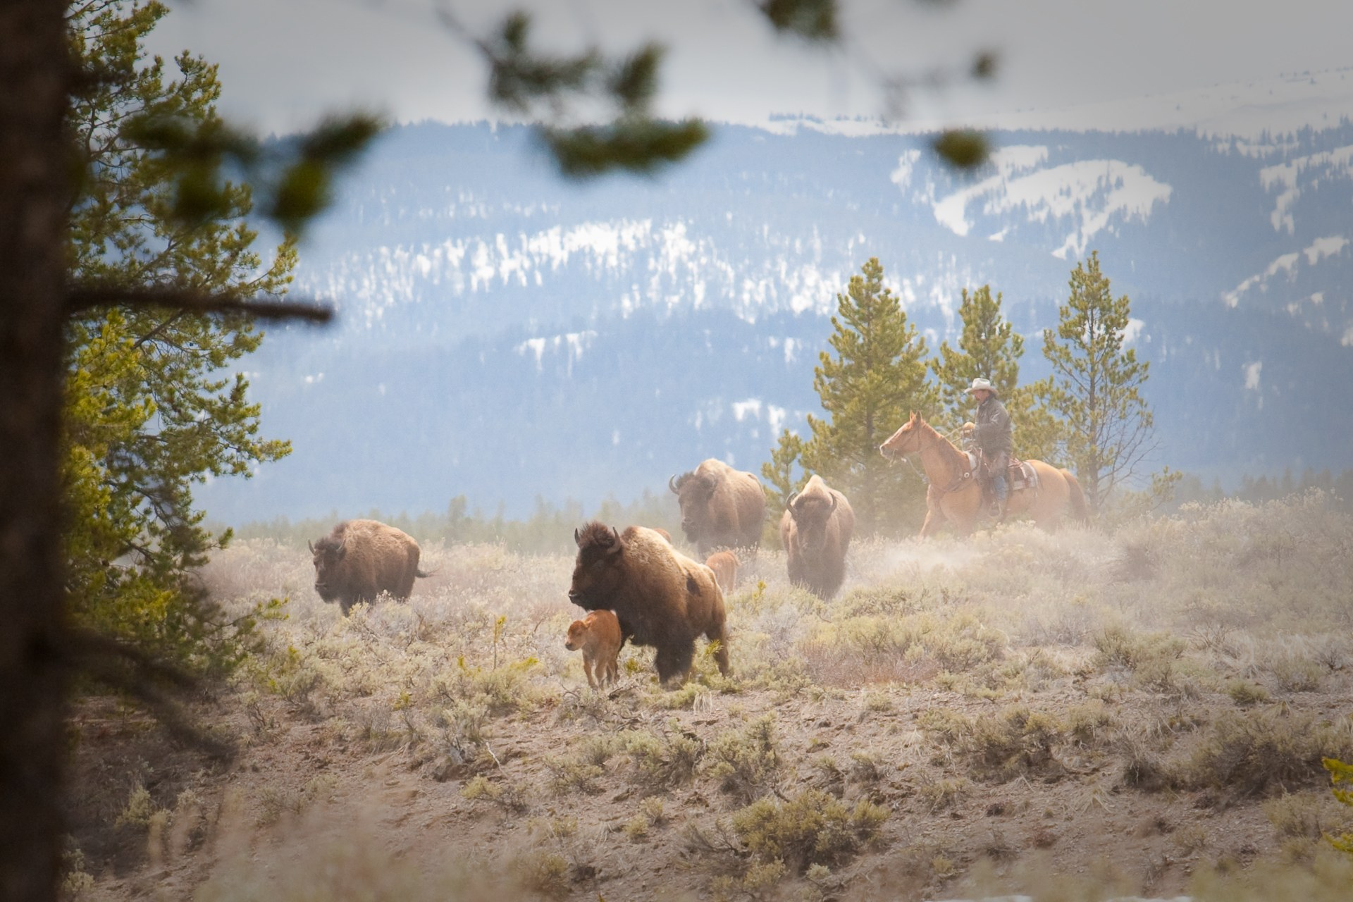
Buffalo Field Campaign photo. Government-led hazing operations targeting the forced removal of buffalo takes place in the absence of cattle, taxing the health of buffalo by moving them away from forage and depleting fat reserves, while disrupting pronghorn antelope, elk, moose, grizzly bears and bald eagles that share the land with buffalo.

216 buffalo have been captured under permit from Yellowstone National Park and held in quarantine pens in the Gardiner basin leased and operated by the U.S. Dept. of Agriculture Animal and Plant Health Inspection Service. Several buffalo were overfed and died trying to give birth to their calves. Half of the buffalo have been slaughtered in an experiment to produce brucellosis-free animals “suitable for the establishment of new public and Native American bison herds or to augment existing populations in North America,” according to Montana Fish, Wildlife & Parks (2004).

None of the quarantined buffalo remaining alive have been allocated for public and Tribal herds leading to a legal dispute by Western Watersheds Project, Buffalo Field Campaign, Gallatin Wildlife Association, and Yellowstone Buffalo Foundation over Montana Fish, Wildlife & Park’s decision to commercialize 3 of 4 offspring in exchange for Turner Enterprises Inc. caretaking the buffalo for five years. As of March 2011, Turner was custodian of 103 quarantined buffalo at his Green Ranch in Montana.

In December 2008, Montana Fish, Wildlife & Parks negotiated a $3,300,000 deal to lease grazing rights for 30 years from the Church Universal and Triumphant on the Royal Teton Ranch west of the Yellowstone River in the Gardiner basin. In January 2011, the initial experiment of capturing, collaring, splitting family groups, and releasing 25 buffalo through an electrified fence onto Cutler Meadows ended in failure in a manner of weeks with two buffalo shot, and the remainder forced back into Yellowstone National Park or held in pens at Stephens Creek, and Corwin Springs.

According to the U.S. Government Accountability Office, the plan is nearly all paid for by American taxpayers with U.S. treasury expenditures of $3,222,345 in fiscal year 2006.

Even if all steps of the plan were achieved, the U.S. Government Accountability Office concluded in its report to the U.S. Congress, the controversy would remain unresolved as the underlying mandates, philosophies, and political interests are in conflict.
Indeed, several conservation, wildlife and American Indian groups filed suit in 2009 claiming the federal agencies have failed to “conduct new or supplemental analysis based on new information and changed circumstances,” provide against the “wanton destruction of bison,” provide for diversity and ensure viability of native species on National Forest lands, have not taken a hard look at environmental impacts and made informed decisions with the best available science about wild buffalo and related species in the Yellowstone ecosystem (online: http://www.buffalofieldcampaign.org/legal/lawsuitinbrief.html).
In February 2011, U.S. District Court Judge Charles C. Lovell dismissed the group’s suit and denied all claims for relief concluding that: “Distasteful as the lethal removal may be to some, it is clearly one of the foremost management tools – time honored – necessarily utilized to protect the species, the habitat, and the public.”
Immediately following Judge Lovell’s opinion and order, Montana Governor Brian Schweitzer issued Executive Order 1-2011 prohibiting Yellowstone National Park from transporting buffalo to slaughter through Montana’s gateway communities.
While the fate of over 650 buffalo trapped in pens is uncertain, public outcry from diverse peoples has stayed certain execution of the buffalo for the 2010-2011winter, and the state of Montana and National Park Service are negotiating new boundaries for the migratory species.

A Buffalo Summit for the Buffalo Nation
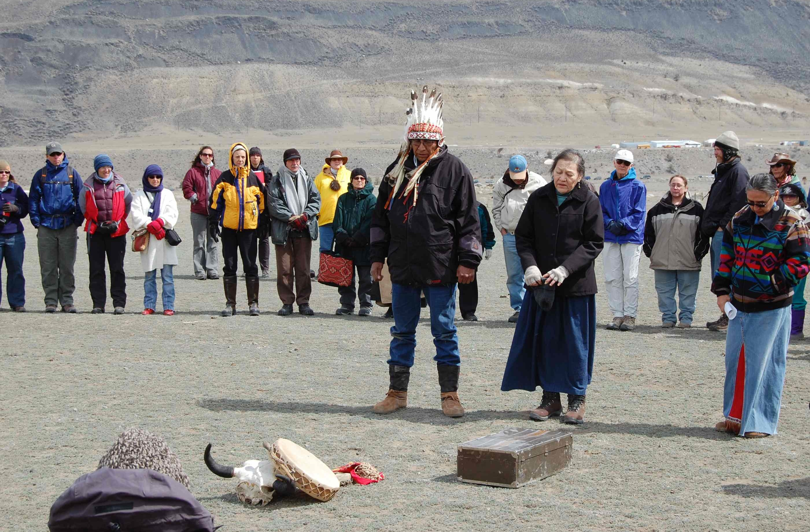
"Let it be known that Yellowstone territory; the habitat of the last wild Buffalo Nation - is sacred ground, it has been a SACRED SITE for the First Nation's people, and for all humanity who hold deep respect for all Creation. The Buffalo Nation has confirmed this fact; by where they have ended up, continuing to survive in their natural migration, struggling to live in a peaceful manner. Our ancestors also gave us this message by fasting in this area long ago, as they recognized this place of sacredness. This understanding is how we maintain the balance upon Un-ci Ma-ka (Grandmother Earth), to protect these places, especially for the survival of our future generations to come." Lakota Chief Arvol Looking Horse
Darrell Geist photo. At the request of tribal elders, Lakota Chief Arvol Looking Horse, 19th Generation Keeper of the White Buffalo Calf Pipe, held a releasing of the buffalo spirits ceremony on April 15, 2008 at the Stephens Creek trap inside Yellowstone National Park to honor the spirits of over one-third of the buffalo herd slaughtered by Yellowstone National Park and the State of Montana during the winter of 2007-2008.

“Executive Order 13175, a directive originally issued by President Clinton on November 6, 2000, calls for regular, meaningful consultation and collaboration with Tribal officials in the development of Federal policy.” National Congress of American Indians, Resolution #ABQ-10-036 2010
In June 2008 an intergovernmental meeting of Yellowstone National Park and American Indian tribes was held in Mammoth. The tribal delegates expressed their frustration over Yellowstone National Park’s neglect of its trust responsibilities, lack of U.S. government decision makers present, the government’s ineffective consultation process, and the continuing slaughter of buffalo by the National Park Service (Tribal Caucus Notes 2008).

During the consultation, tribal delegates called for a cessation of the meeting for prayer and to caucus on how to proceed in the face of these circumstances. Delegates emerged from the tribal caucus pledging to convene a Buffalo Summit and in November 2010 the National Congress of American Indians invited President Obama to meaningful Nation-to-Nation consultation to “end the decimation of the buffalo herds.”

Tribal organizers have met with a positive reaction and a willingness to participate from American Indian tribes and officials in Obama’s administration.

In a statement of support, Chief Arvol Looking Horse commented, “Such an agreement would not come easy nor can it be reached in one discussion, but we invite him to sit with us to begin an honorable Nation-to-Nation consultation process. Great things can be achieved when good spirits come together in honor.”

Tribal organizers are working to convene a Buffalo Summit in Fall 2011 to begin an intergovernmental process to engage leaders from the U.S. Department of the Interior, Yellowstone National Park, and American Indian tribes addressing tribal concerns and interests over buffalo management.

A Buffalo Summit may prove to be a pivotal moment in history on the future of the Buffalo Nation, American Indian cultures, and for all people who embrace the natural heritage of wild migratory buffalo for generations to come.

Sources online: http://www.buffalofieldcampaign.org/legal/tribalbriefing.html
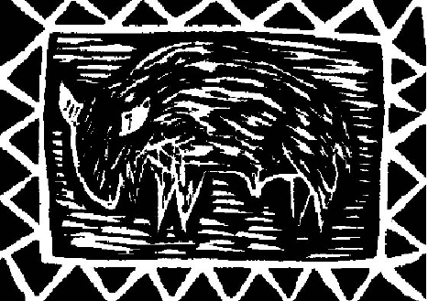
March 2011 prepared by Darrell Geist,
habitat coordinator, Buffalo Field Campaign
PO Box 957, West Yellowstone, Montana 59758
Phone: (406) 646-0070 Fax: (406) 646-0071
Email: buffalo@wildrockies.org
Web: www.buffalofieldcampaign.org

