CURRENT CHALLENGES TO THE
POLICY AND LEGAL FRAMEWORK GOVERNING YELLOWSTONE BISON IN THEIR NATIVE RANGE

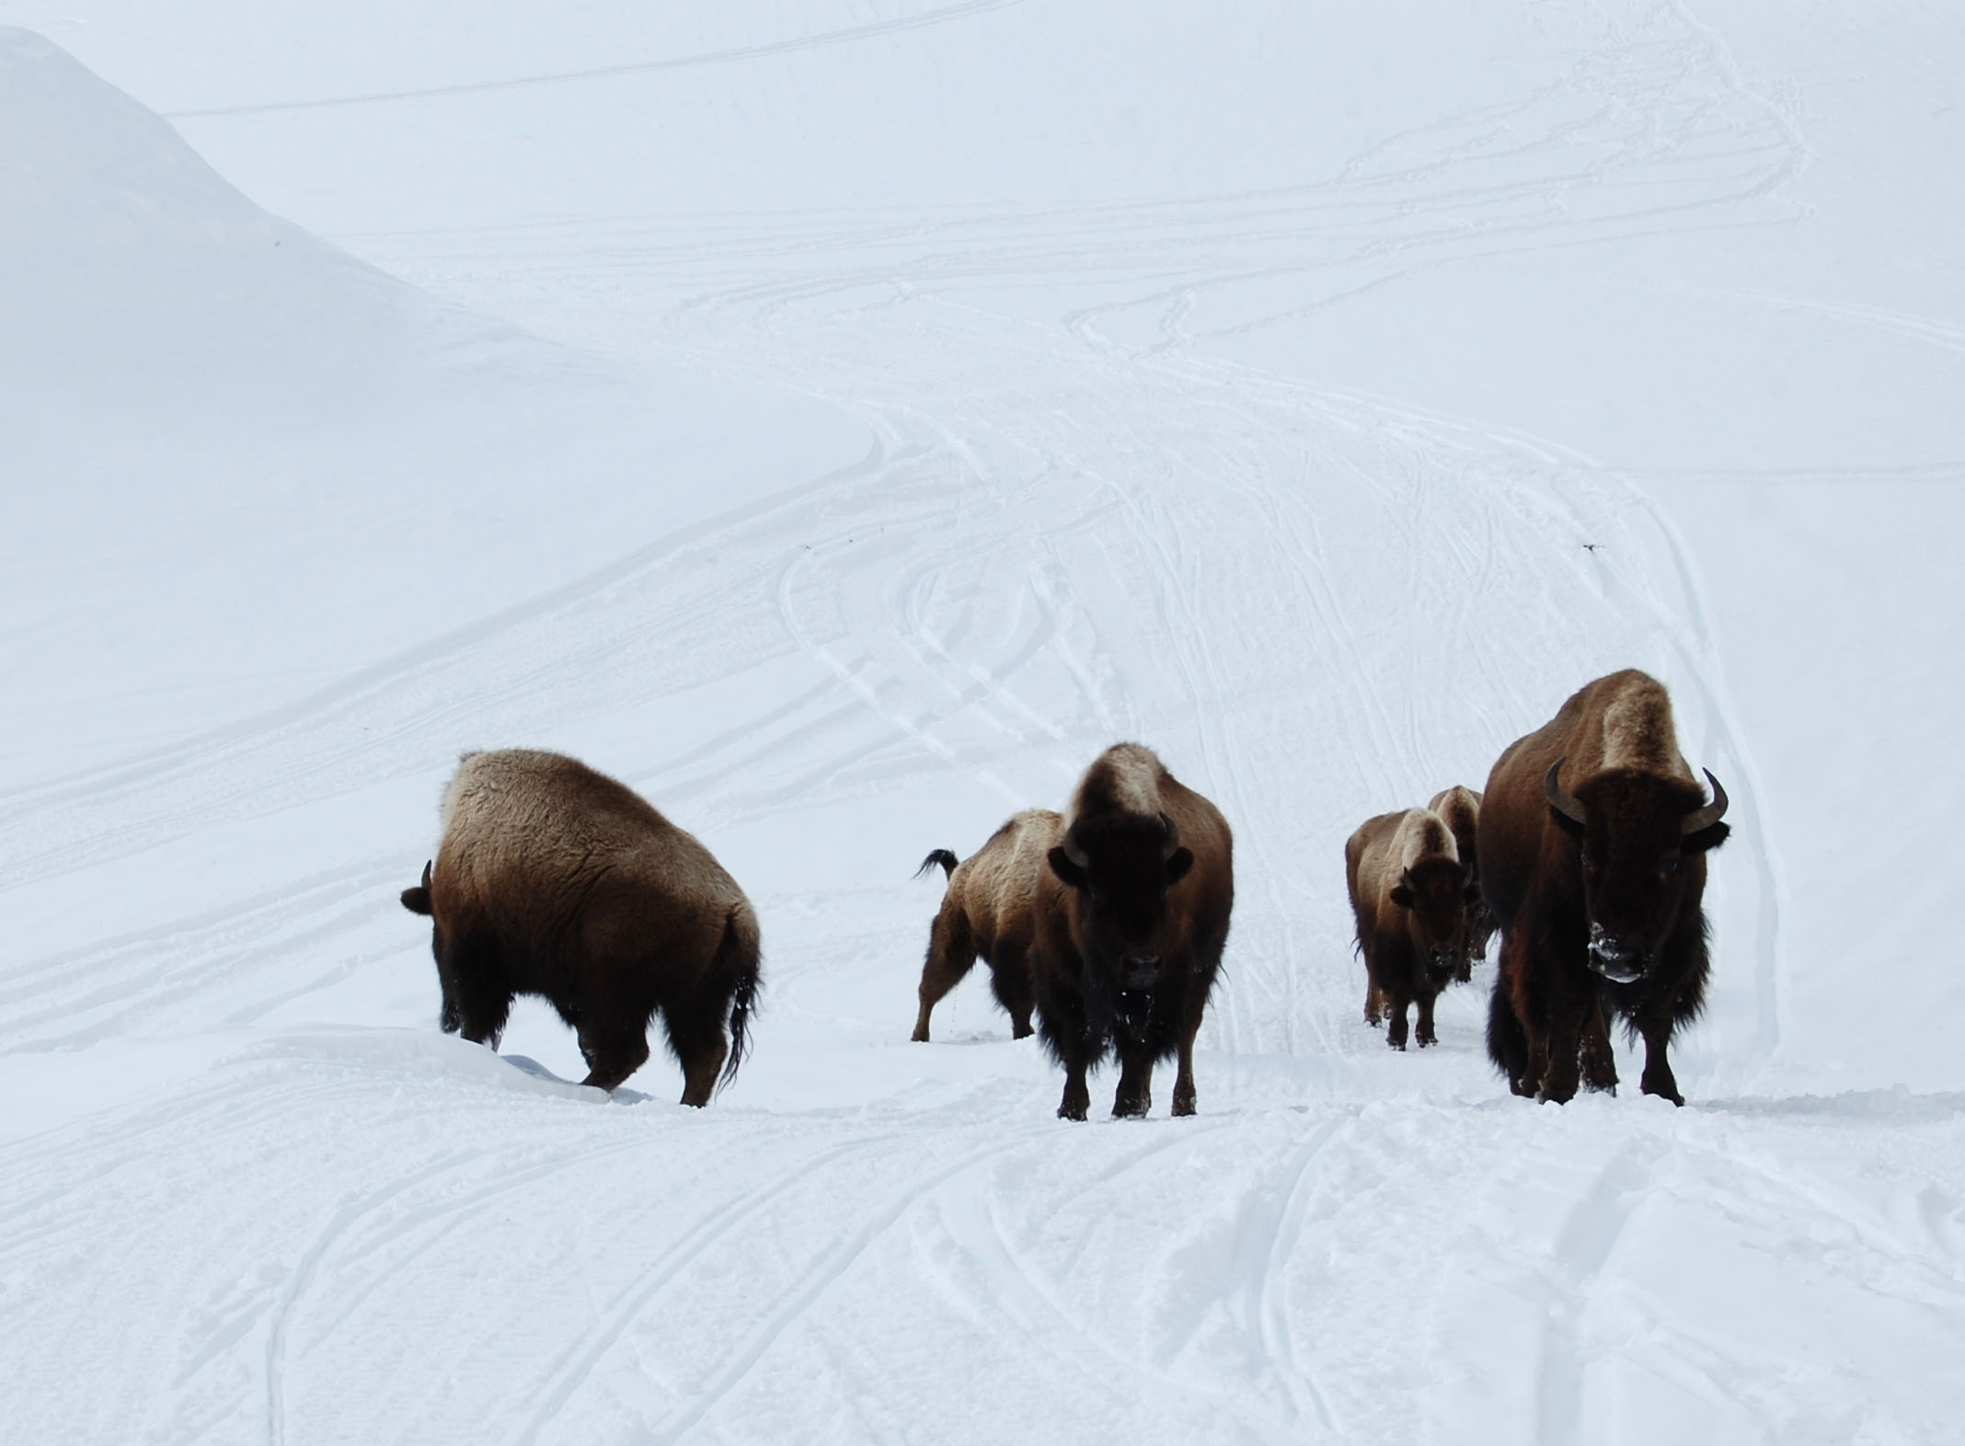
Yellowstone bison, Hebgen Lake, West Yellowstone, Montana, March 2008.

Draft briefing report
Updated June 26, 2008
Darrell Geist, habitat coordinator
Buffalo Field Campaign

2007-2008 OVERVIEW OF INTERAGENCY BISON MANAGEMENT PLAN ACTIONS TARGETING YELLOWSTONE BISON

Records of decision, environmental analysis, and public comment on the governing Interagency Bison Management Plan are online: http://www.buffalofieldcampaign.org/aboutbuffalo/bisonmanagementplan.html

The winter of 2007-2008 will be remembered as the largest scale wild buffalo slaughter since the 19th century.

Since its inception in 2000, the multimillion taxpayer funded Interagency Bison Management Plan has eliminated almost 3,700 wild buffalo from the Yellowstone ecosystem, mainly on public lands in America's flagship Yellowstone National Park and the Gallatin National Forest.

This season's slaughter or removal counted over 1,725 wild buffalo, surpassing that of 1996-1997 when 1,084 buffalo were killed.

One-third of the entire Yellowstone herd has been wiped out with 1,276 buffalo trapped and shipped to slaughterhouses on order from officials in the National Park Service under Superintendent Suzanne Lewis. A total of 1,645 wild buffalo were captured at Stephens Creek inside the Park.

Over 60 government-led hazing operations targeting the forced removal or harassment of buffalo occurred this season, depleting the health of buffalo by moving them away from forage and depleting fat reserves, while repeatedly disrupting wildlife species like pronghorn antelope and bald eagles that share the land with buffalo.

Six bison were shot in the field for migrating into a drop-dead zone near Yankee Jim Canyon and Maiden Basin along the Yellowstone River.

Eighty-one buffalo calves were born in captivity. Several calves were born dead or died shortly after birth inside the trap. Ten wild buffalo died or were euthanized as a result of injuries while held in National Park Service’s trap at Stephens Creek.

One hundred twelve buffalo calves have been separated from their mothers and family groups and sent to quarantine pens near Corwin Springs, Montana operated by the U.S. Department of Agriculture. Those calves are in addition to 45 buffalo quarantined at Slip N Slide Ranch near Dome Mountain.

The Montana Department of Livestock under Governor Brian Schweitzer has targeted buffalo in hazing operations that led to the capture of 158 wild bison migrating into the upper Madison Valley and Hebgen Lake Basin and their subsequent shipment to slaughterhouses.

The State of Montana's hunt ended in February 2008 with 63 wild buffalo killed. Nez Perce hunted 64 buffalo under treaty rights. Salish-Kootenai also hunted 39 buffalo this season.

The Park Service’s summer count estimated 4,700 buffalo. It is uncertain how many buffalo remain from this season’s slaughter and winterkill. The last publicly reported population count by the Park Service in early April found 1,970 buffalo.

In May 2008, Yellowstone National Park released 333 wild buffalo trapped at Stephens Creek, forcing them out of the Gardiner Basin to the Blacktail Plateau, their hides glued with tags identifying them as survivors of a deadly, ignorant plan that imperils America’s last wild buffalo.
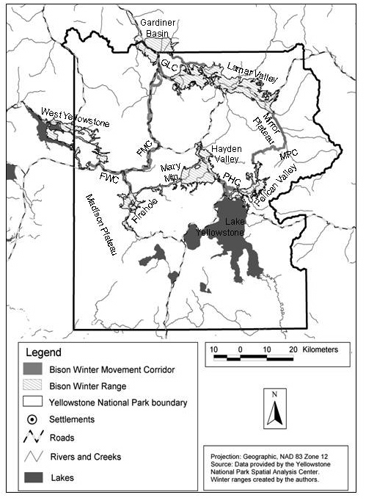
Bison winter range and migration corridors from Gates et al, THE ECOLOGY OF BISON MOVEMENTS AND DISTRIBUTION IN AND BEYOND YELLOWSTONE NATIONAL PARK, A Critical Review With Implications for Winter Use and Transboundary Population Management, 2005.
EMERGENCY RULE MAKING PETITION TO STOP THE BISON SLAUGHTER
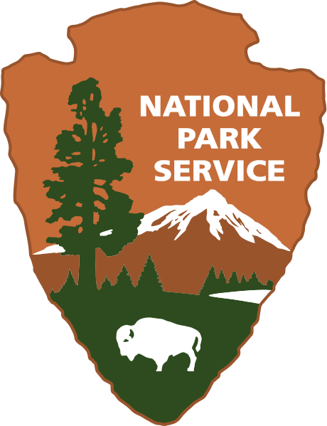
You can sign on and download the emergency stop the Yellowstone bison slaughter petition online: http://www.buffalofieldcampaign.org/stoptheslaughter.html

As decreed by an Act of the U.S. Congress, the mission of the U.S. National Park Service is to:

“promote and regulate the use of the Federal areas known as national parks, monuments, and reservations … by such means and measures as conform to the fundamental purpose of the said parks, monuments, and reservations, which purpose is to conserve the scenery and the natural and historic objects and the wild life therein and to provide for the enjoyment of the same in such manner and by such means as will leave them unimpaired for the enjoyment of future generations.”
National Park Service Organic Act (16 U.S.C. §1 et seq.)

A diverse coalition of tribal, conservation, hunting, animal welfare and wildlife groups, an outfitting business, and concerned citizens from Montana and South Dakota, filed an emergency rule making petition April 10, 2008 with the U.S. Department of the Interior seeking to stop the National Park Service from slaughtering wild bison inhabiting Yellowstone National Park and adjoining lands on the Gallatin National Forest in Montana.

The coalition requested immediate measures be taken by the National Park Service to ensure bison's long-term survival and health including protecting a minimum of 2,000 bison in each distinct bison population. That number is considered a minimum for each population to retain genetic diversity over a 200 year time period (Gross and Wang 2005; Gross et al. 2006). Maintaining 2,000 bison in each distinct population would ensure that genetic diversity is conserved - allowing Yellowstone bison to naturally evolve and adapt to a changing environment, and retain important survival traits like natural migration and selection.

The petition presents scientific evidence of at least two genetically distinct bison populations inhabiting Yellowstone National Park: the Central range herd inhabiting Pelican Valley, Hayden Valley, and the Firehole region, and the Northern range herd inhabiting the Lamar Valley.

Petitioners argue and present evidence that the Interagency Bison Management Plan does not contain sufficient controls or conservation measures for Yellowstone’s distinct bison populations. The interagency partners have also systematically failed to adapt to emerging bison science, research and changed circumstances that favor conservation of wild bison and their habitat.

The petition asked Secretary of the Interior Dirk Kempthorne to publish an emergency rule prohibiting the National Park Service from killing or otherwise permanently removing bison from either population when the population is reduced to 2,000 or fewer bison. Northern range and Central range bison populations number fewer than this conservation threshold.

On May 19, 2008, Michael D. Snyder, the Regional Director for the National Park Service’s Intermountain Region responded that the petition was not warranted as the plan was proceeding to Step 2 on the Royal Teton Ranch in the Gardiner Basin and that it was “important to allow these changes to take place, as well as any other adaptive management changes, before considering any emergency rulemaking.”

Additionally, the Park Service noted that in the face of uncertainties about conserving Yellowstone bison genetics, the agency would present petitioners “analysis and argument at the next meeting of the IBMP partner agencies and recommend an assessment of how this recent science should be incorporated through the IBMP adaptive management framework.”

Signatories to the petition: Animal Welfare Institute, Buffalo Field Campaign, GravelBar, Natural Resources Defense Council, American Buffalo Foundation, Western Watersheds Project, Seventh Generation Fund for Indigenous Development, Horse Butte Neighbors of Buffalo, Big Wild Adventures, Gallatin Wildlife Association, American Indian Law Alliance, The Humane Society of the United States, WildEarth Guardians, Ms. Karrie Taggart, Ms. barb abramo, Mr. George Nell, and Ms. Rosalie Little Thunder.

For additional information on the emergency rule making petition, contact: D.J. Schubert, Animal Welfare Institute, (609) 601-2875, dj@awionline.org or Darrell Geist, Buffalo Field Campaign, (406) 646-0070, z@wildrockies.org

Excerpt from the Emergency Rule Making Petition:

“Within a species, genetic diversity provides the mechanism for evolutionary change and adaptation (Allendorf and Leary 1986, Meffe and Carroll 1994, Chambers 1998). A reduction in genetic diversity can cause a reduction in fitness, decreased growth, increased mortality, increased susceptibility to disease, and a reduction in the flexibility of individual animals to adapt to evolutionary changes (Ballou and Ralls 1982, Mitton and Grant 1984, Allendorf and Leary 1986, Berger and Cunningham 1994). Genetic diversity can be reduced as a product of hybridization (e.g., with cattle), inbreeding, founder effects, genetic drift, and as a consequence of domestication where purposeful selection will favor some morphological/behavioral/physiological traits over others ultimately leading to genomic extinction (Freese et al. 2007) of bison as a wildlife species.

In general, populations with a genetically effective population size of 50 to 500 were considered secure (Meffe and Carroll 1995). Gross et al. (2006) report that populations containing fewer than 500 breeding individuals are believed to be especially vulnerable to harmful consequences of inbreeding depression and other impacts that can be directly traced to the genetic composition of the populations (Frankham 1995, Keller and Waller 2002).”
HORSE BUTTE BISON HABITAT

You can sign on and download the Horse Butte bison habitat letter to the people in charge of the Interagency Bison Management Plan requesting that wild bison be allowed to roam on Horse Butte online: http://www.buffalofieldcampaign.org/legal/horsebutte.html

On March 3, 2008 local Montana residents, Buffalo Field Campaign, and Earthjustice sent a letter to the people in charge of bison management requesting that Horse Butte, a 9,600 acre peninsula in the upper Madison Valley, be designated bison habitat, and that the government no longer harm bison migrating to this critical habitat.

The letter formally requested that the government cease all bison hazing, harassment and slaughter until a supplemental environmental impact statement is prepared analyzing the changed circumstances that favor allowing bison to roam on Horse Butte.

Elimination of cattle grazing on Horse Butte and local neighborhood support for wild bison creates an opportunity to allow wild bison to migrate to and occupy critical winter range and spring calving habitat on Horse Butte Peninsula.

Over 20,300 people signed on to Earthjustice's plea to let bison roam on public lands and in support of 69 local Montana residents who welcome bison on Horse Butte.

On May 14, 2008, John R. Clifford APHIS’ Deputy Administrator for Veterinary Services responded to the local plea “to allow buffalo that have strayed from the Yellowstone National Park to remain on the Horse Butte Peninsula in Montana.”

Clifford wrote: “Any initiative to discontinue removing park bison from the Horse Butte Peninsula would require the approval of the Montana State Veterinarian. Further, the owners of the private property on Horse Butte Peninsula and the Montana Department of Livestock would need to agree on establishing a workable plan to allow the presence of bison on Horse Butte and for the permanent removal of cattle from the property.”

Additionally, Cliffod wrote that APHIS and its partner agencies will discuss changes on Horse Butte in “operational meetings” in 2008. “Using sound science, including the fact that the area has not been recognized as traditional bison calving ground over the years, the IBMP partners will evaluate whether changes involving the management of bison in the area are appropriate.”

Information on the ecological and cultural importance of Horse Butte can be found online: http://www.buffalofieldcampaign.org/science/horsebutte.html

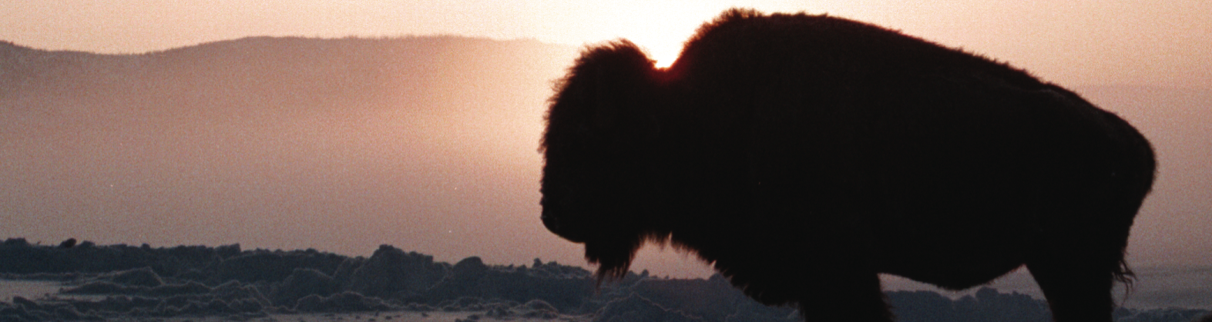
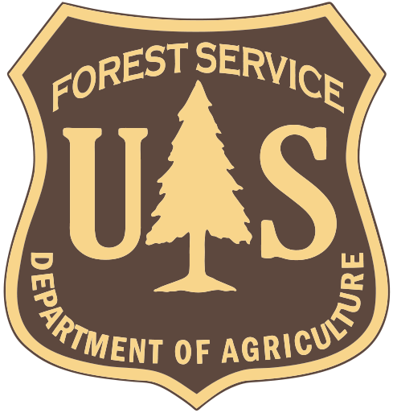
HORSE BUTTE BISON TRAP AND LAND USE DECISIONS ON THE GALLATIN NATIONAL FOREST

Buffalo Field Campaign has raised several concerns on a proposed decision by the U.S. Forest Service to renew a 10-year special use permit for the Montana Department of Livestock’s Horse Butte bison trap on the Gallatin National Forest. The U.S. Forest Service’s March 2008 public notice on the Horse Butte bison trap is available online: http://www.fs.fed.us/r1/gallatin/?page=projects/horse_butte

A decision from the U.S. Forest Service on the fate of the livestock agency’s bison trap is expected in the fall of 2008.

Buffalo Field Campaign and Western Watersheds Project scoping comments and documents submitted on the Montana Department of Livestock’s Horse Butte bison trap are online: http://www.buffalofieldcampaign.org/legal/bisontrap.html

The U.S. Forest Service's "principal role" in the Interagency Bison Management Plan is to "provide habitat for bison" (Bison Management Plan for the State of Montana and Yellowstone National Park 2000). Renewing the Montana Department of Livestock's bison trap on Gallatin National Forest lands diminishes available bison habitat, disrupts bison's natural migration, and unnecessarily harms wild bison migrating to public lands on the Gallatin National Forest.

On the Gallatin National Forest, the Hebgen Lake Ranger District and Gardiner Ranger District encompass the upper reaches of the Madison River, Gallatin River, and Yellowstone River valleys, the primary corridors for wild bison migrating from the Yellowstone plateau.

Over 105,000 acres of Gallatin National Forest lands are permitted for grazing private livestock on the Hebgen Lake and Gardiner Ranger Districts (Geist 2007). Actual and potential bison habitat exists on Gallatin National Forest lands surrounding Yellowstone National Park. Permitting private cattle grazing, particularly cow/calf pairs, and fencing off native wildlife habitat precludes wild bison from inhabiting Gallatin National Forest lands on a seasonal and year-round basis.

In 2002, a US District Court ruling vacated the Horse Butte cattle grazing permit and enjoined the Gallatin National Forest from reissuing the allotment without proper National Environmental Policy Act review (Greater Yellowstone Coalition et al v. Dale Bosworth et al. 2002). No valid cattle grazing permit remains in use on the 9,600 acre Horse Butte peninsula. With this changed circumstance, Buffalo Field Campaign recommended the Horse Butte grazing permit be permanently closed, and that the Gallatin National Forest adhere to its "principal role" in the interagency plan and "provide habitat for bison" by managing this closed allotment for migrating bison.

Bison hunting, proposed and existing bison traps and quarantine pens on federal, state, and private lands, and permitting the grazing and fencing of domestic livestock in bison’s native habitat on National Forest lands in the Gallatin National Forest is contributing to the loss of habitat for wild bison migrating from Yellowstone National Park along the Madison River, Gallatin River and Yellowstone River valleys.

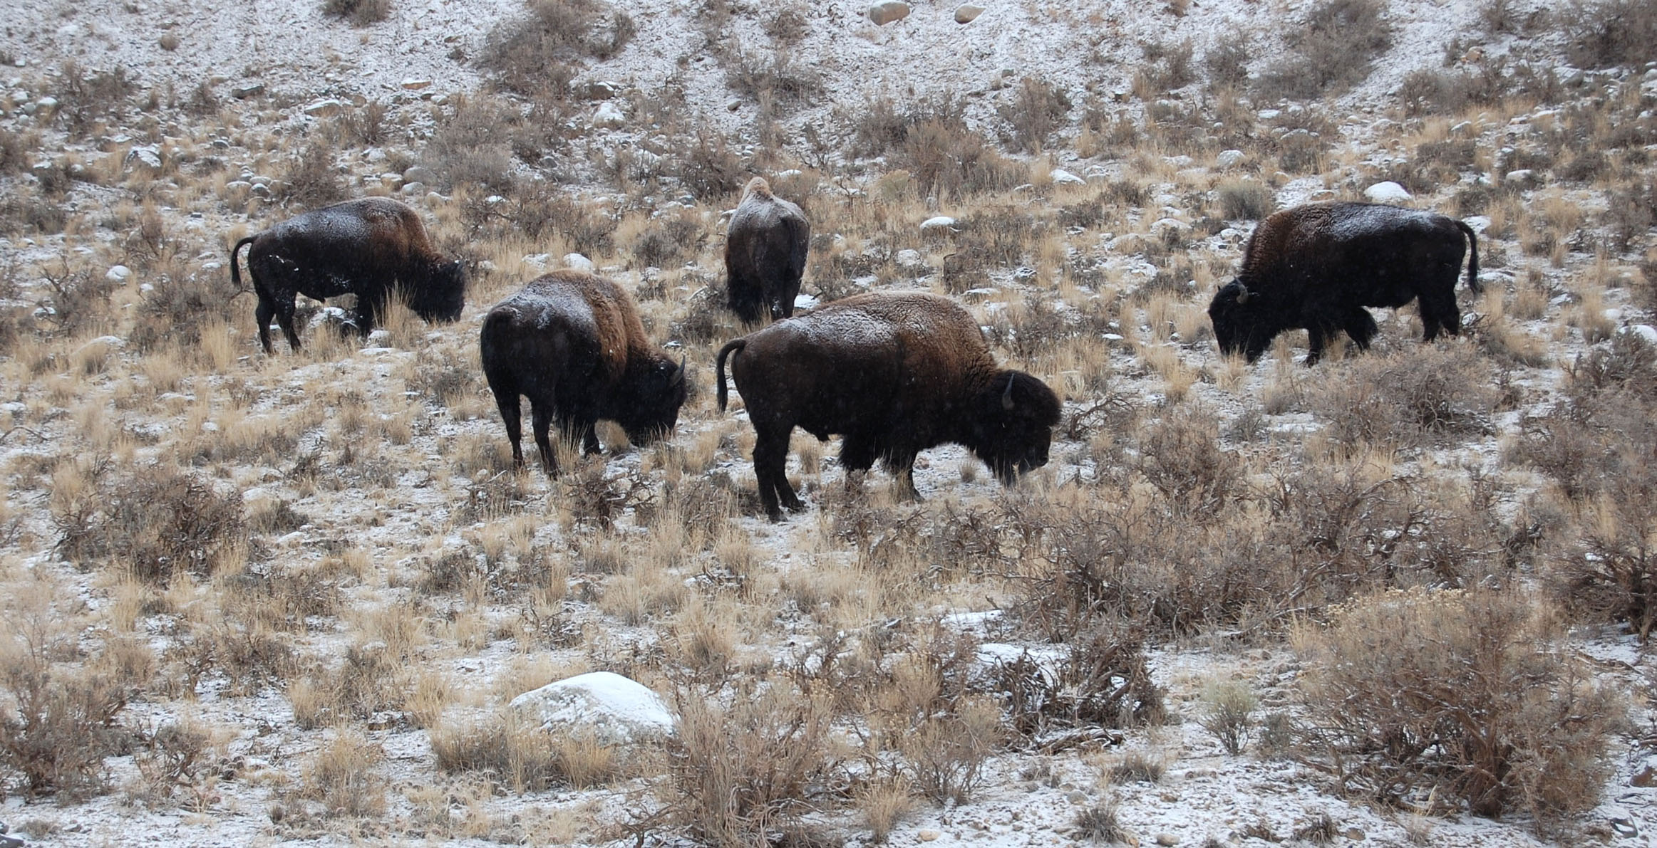
Bison grazing on winter range along Jardine Road near Eagle Creek, December 2007.

Several land use decisions made by the U.S. Department of Agriculture and U.S. Forest Service illustrate the loss of available habitat for migrating bison on National Forest lands and adjacent private lands:

• Opening 23,000 acres in the Eagle Creek drainage to Montana’s bison hunt harmed wild bison wintering on Gallatin National Forest lands on the Gardiner Ranger District.
• Permitting the Montana Department of Livestock’s Horse Butte bison trap in 1998 has displaced wild bison from habitat on Horse Butte peninsula – 9,600 acres of Gallatin National Forest lands on the Hebgen Lake Ranger District that support an array of wildlife including grizzly bears, wolves, bald eagles, moose, and rare plant species like dwarf monkey flower.
• Completion of the 6,770 acre Royal Teton Ranch land conservation deal in the Gardiner basin in 1999 which the U.S. Forest Service was party to has failed to “provide a safe haven” for wild bison.
• The Gallatin National Forest's decision to renew for 10 years the Cache- Eldridge cattle grazing permit in the Taylor Fork Gallatin River drainage in potential bison winter range according to Montana Fish, Wildlife and Parks biologist Jourdannais (2006).
• The U.S. Forest Service acquisition of the 3,265 acre OTO Ranch in Cedar Creek bison winter range (Lemke 2006) east of the Yellowstone River in the Gardiner basin that bison are excluded from occupying in arbitrary "zone" management boundaries defined in the interagency plan.
• The U.S. Department of Agriculture's bison quarantine holding pens at Corwin Springs and Slip N Slide east of the Yellowstone River in the Gardiner basin have effectively displaced bison and harmed bison winter range as mapped by Montana Fish, Wildlife and Parks biologist Lemke (2006).

The cumulative effect of the U.S. Forest Service's grazing program and decisions on land use on National Forests is in direct conflict with the principal role prescribed for it, “to provide habitat for bison” and the Gallatin National Forest must correct its decision making to manage public lands for this indigenous wildlife species.


U.S. GOVERNMENT ACCOUNTABILITY OFFICE REPORT ON YELLOWSTONE BISON RELEASED

A copy of GAO's report “YELLOWSTONE BISON, Interagency Plan and Agencies’ Management Need Improvement to Better Address Bison-Cattle Brucellosis Controversy” is online: http://www.gao.gov/docsearch/abstract.php?rptno=GAO-08-291

A U.S. Government Accountability Office report made public April 2, 2008 sharply criticized a slew of federal and state agencies behind the Interagency Bison Management Plan, the governing document responsible for the slaughter of nearly 3,700 wild American buffalo in and around Yellowstone National Park.

In a press release, House Natural Resources Committee Chairman Nick J. Rahall (D-WV) and Rep. Maurice Hinchey (D-NY) criticized the bison plan as "plagued by deficiencies" and "severely limited" in its ability to protect Yellowstone's wild bison population.

"The entire process must be reorganized and opened up for oversight by Congress and the public," Rep. Hinchey said. Rep. Rahall was also quoted saying: "It has been clear for some time now that the current Interagency Bison Management Plan is not working."

The GAO reports: "The interagency bison management plan does not have clearly defined, measurable objectives, and the partner agencies share no common view of the objectives. Consequently, the agencies have no sound basis for making decisions or measuring the success of their efforts... Additionally, the agencies have not designed a monitoring program to systematically collect data from their management actions, nor have they set forth a coordinated research agenda to resolve remaining critical uncertainties related to bison and brucellosis-related issues."

As the GAO reports, the bison plan is nearly all paid for by American taxpayers with expenditures from the U.S. treasury reaching a high of $3,222,345 in 2006 (FY).

Among the key findings, the GAO report found:

• "... the agencies lack accountability among themselves and to the public, and it is difficult for the public to obtain information without attending the meetings or contacting each individual agency."

• "In the absence of a systematic monitoring program, the agencies have lost opportunities to collect data that could help resolve important uncertainties. The plan states that all captured bison are to be tested for exposure to brucellosis, but fewer than half of those captured since 2001 have been tested. For example, in early winter 2006, the agencies lost an opportunity to collect scientific data on about 900 bison. Park Service officials captured these bison as they attempted to leave through the park's northern boundary. The bison were consigned to slaughter without being tested at the capture facility because the Park Service determined that they would not be used for research and could not be held in the capture pens until the spring for release back into the park."

• "The plan specifically states that it does not identify how the agencies will measure success or failure. In fact, several agency officials acknowledged that they had not identified metrics or parameters for measuring how well they are meeting the plan's stated goals."

The GAO report found that the agencies are failing to follow their promise to test bison destined for slaughter - and resolve an uncertainty in their testing which, to date, does not determine infection or the health of bison: "According to the U.S. Geological Survey, a published study by researchers at the Idaho National Engineering and Environmental Laboratory (now known as the Idaho National Laboratory) has shown that it is possible to detect Brucella abortus DNA in blood samples rather than antibodies to Brucella abortus and thereby determine actual infection… Current brucellosis tests involve determining whether a blood sample taken from an animal contains antibodies to the brucellosis bacterium. The presence of these antibodies indicates that the animal has been exposed to the bacterium in quantities sufficient to trigger antibody production but does not necessarily mean the animal is infected with, or ill from, the disease itself."

Eight years into a fifteen year plan, the GAO report found that the agencies are stuck in step one, with no timeline on how to get out of this step the most deadly and intrusive one for migrating bison: "The agencies have no estimate regarding how long it will take to meet the conditions for starting step two, nor have they revised their estimated dates for reaching step three, which was expected by winter 2005-2006."

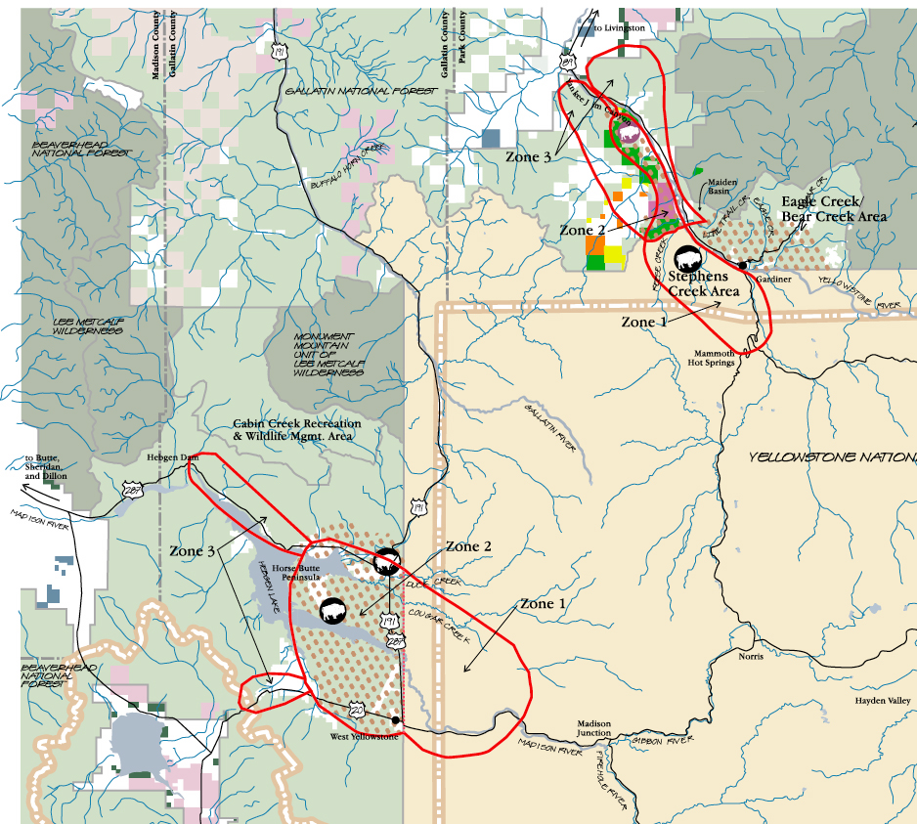
Yellowstone bison zone management, Interagency Bison Management Plan, 2000. “Tolerance” for bison migrating into the zones decreases in each zone with Zone 3 as a lethal management zone.
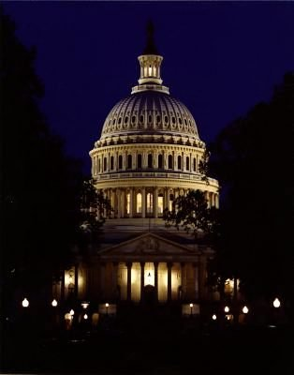
U.S. CONGRESSIONAL HEARINGS ON YELLOWSTONE BISON

On March 20, 2007 the House Natural Resources Committee, Subcommittee on National Parks, Forests and Public Lands, chaired by Rep. Raúl Grijalva (D-AZ), held an oversight hearing on Yellowstone National Park bison in Washington D.C.

The oversight hearing came in response to mounting criticism by wildlife advocates of a waste of taxpayer money on a costly government plan that threatens America's last wild bison herd in Yellowstone National Park.

Congressional oversight hearing transcripts, audio, and documents submitted into the U.S. Congressional Record on Yellowstone bison are online:
http://www.buffalofieldcampaign.org/legislative/congresshearing032007.html

Rep. Grijalva set the tone for the hearing and stated: "The slaughter of bison needs to stop." His comment was echoed by Rep. Nick J. Rahall II (D-WV) who said, “The slaughter of bison is not required in order to manage the threat of disease. Slaughter is not management. It is an approach from a bygone era, and has no place in a time of rapid scientific and economic progress. We are capable of more ingenuity and more compassion if we are willing to try.”

Mike Soukup, Associate Director of the National Park Service, said in written comments: “Bison are an integral part of a visitor’s experience in the natural system of Yellowstone National Park. Today the Yellowstone bison herd is the nation’s only continuously free-roaming herd, a small but precious genetically true remnant of the vast herds of bison that once roamed this continent. While many consider the bison emblematic of our nation’s natural heritage, as a species it has not fared well.”

Also testifying at the Congressional hearing were Montana's Governor Brian Schweitzer, Josh Osher of Buffalo Field Campaign, Tim Stevens from the National Parks Conservation Association, Wayne Pacelle, President and CEO of the Humane Society of the United States.

In a sharp criticism of the Interagency Bison Management Plan, Robin Nazzaro, U.S. Government Accountability Office Director of Natural Resources and Environment, wrote in testimony to the subcommittee:

“… [Eight years] after approving the IBMP, the five federal and state partnering agencies remain in step one of the three-step plan because cattle continue to graze on certain private lands. A key condition for the partner agencies progressing further under the plan requires that cattle no longer graze in the winter on certain private lands adjacent to the north boundary of Yellowstone National Park and west of the Yellowstone River to minimize the risk of brucellosis transmission from bison to cattle. The agencies anticipated meeting this condition by the winter of 2002/2003. Until this condition is met, bison will not be allowed to roam freely beyond the park’s northern border, west of the Yellowstone River. The Forest Service has been successful in purchasing certain private lands and continues its vacancy of national forest grazing allotments in the area; however, the partner agencies have yet to acquire cattle grazing rights on other private lands adjacent to the north boundary of Yellowstone National Park and west of the Yellowstone River. While a prior attempt by Interior was unsuccessful, Montana’s Department of Fish, Wildlife and Parks is currently negotiating with the private land owner to acquire these grazing rights.”

ROYAL TETON RANCH LAND DEAL

Maps and fact sheets on the Royal Teton Ranch land deal, and a 30-year lease to remove cattle from Church Universal and Triumphant lands west of the Yellowstone River are available online: http://www.buffalofieldcampaign.org/legal/rtr.html

In 1999, the US Department of Interior and the US Forest Service used $13,056,503.83 in taxpayer funds appropriated by the U.S. Congress to acquire and conserve land for native wildlife owned by the Church Universal and Triumphant west of the Yellowstone River in the Gardiner basin.

The land deal included the purchase of 5,262 acres of Church lands in Cutler Meadows, North Dry Creek, Bassett Creek and Royal Teton Ranch lands between Yankee Jim Canyon and Cinnabar Mountain, near Yellowstone National Park, and a conservation easement for wildlife habitat on 1,508 acres near Devil’s Slide (USFS Gallatin National Forest Briefing Paper, Royal Teton Ranch Land Conservation Project, Current 2003; RTR Purchase Summary with Funding Breakdown January 20 2000 Updated March 6, 2000 to include Phase II closing costs).

Buffalo Field Campaign has long advocated that wild bison migrating along the Yellowstone River in the Gardiner Basin be allowed to range on public lands under U.S. Forest Service authority, and lands acquired and conserved under the taxpayer funded $13,000,000 Royal Teton Ranch land deal.

As part of the 1999 land deal, the Church Universal and Triumphant and the U.S. Forest Service promised to produce a Bison Management Plan and provide a "safe haven for the bison" on lands the public purchased and conserved:

"Whereas, the Grantor finds itself in a unique position to aid and assist in the preservation of the Yellowstone National Park bison and other wildlife by setting aside a portion of its lands, in perpetuity, thereby providing in the natural world, a safe haven for the bison; and Whereas, the Grantor's lands provide significant winter range and crucial habitat for many indigenous species including elk, bighorn sheep, mule deer, pronghorns, grizzly and black bears, mountain lions, other indigenous wildlife, and, upon completion of the Bison Management Plan, significant winter range and crucial habitat for bison;" (Deed of Conservation Easement, Royal Teton Ranch, Devil's Slide Area August 30, 1999, Section VII).

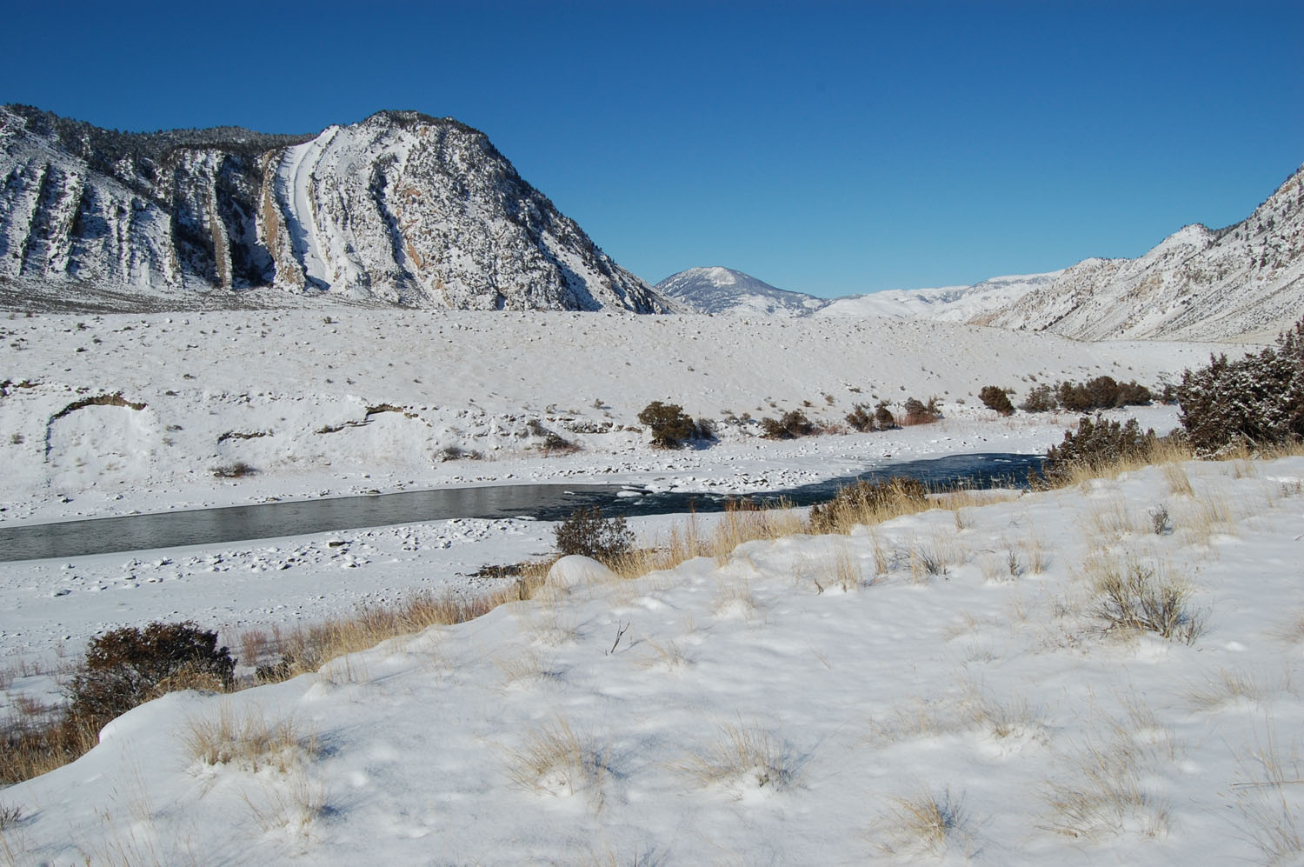
The “safe haven for the bison” on the Royal Teton Ranch never materialized. As a consequence, bison migrating into Gardiner Basin have been forced into a trap at Stephens Creek inside Yellowstone National Park. Thousands of bison have been sent to slaughterhouses as there is no plan for bison to roam on the Royal Teton Ranch, downriver to lands purchased from the Church, and U.S. Forest Service lands west of the Yellowstone River.

Currently, several nonprofit and government parties are negotiating a $2,800,000 deal to lease private Church lands and remove cattle under the terms of a 30-year lease. Devil’s Slide, Yellowstone River

Yellowstone National Park has pledged $1,500,000 for the lease agreement, the State of Montana $300,000 with the other million to be raised by Greater Yellowstone Coalition, National Wildlife Federation, and National Parks Conservation Association.

As of June 26, 2008 no final agreement with funding in hand has been reached.

There is a valid concern that what the public has already paid for with taxpayer money in 1999 - with no benefit to wild bison despite its promise - will be paid for again by the public through a 30-year lease to remove cattle from Church Universal and Triumphant lands west of the Yellowstone River in the Gardiner Basin to Yankee Jim Canyon.

The draft terms of the 30-year lease would permit 25 bison through a fenced corridor seasonally from December 1 to April 15 to U.S. Forest Service lands adjacent to and north of the Royal Teton Ranch along the west side of the Yellowstone River. Bison permitted through the Church corridor would first be hazed and trapped at Yellowstone National Park’s Stephens Creek trap. Bison tested who showed no immune response indicating exposure to brucellosis will be collared or marked and females implanted with telemetry devices. Bison migrating onto U.S. Forest Service lands downriver to Yankee Jim Canyon will be hunted on a limited basis. Another bison trap on U.S. Forest Service lands may be permitted to enforce the April 15 dead line. If Step 3 in the interagency bison plan is reached, up to 100 bison may be allowed to roam on these lands as outlined in the draft lease agreement.

A copy of the draft lease agreement and map of the fenced corridor where bison could roam west of the Yellowstone River is online: http://www.buffalofieldcampaign.org/legal/rtr.html

US FISH & WILDLIFE SERVICE ENDANGERED SPECIES ACT PETITON FINDING ON YELLOWSTONE BISON

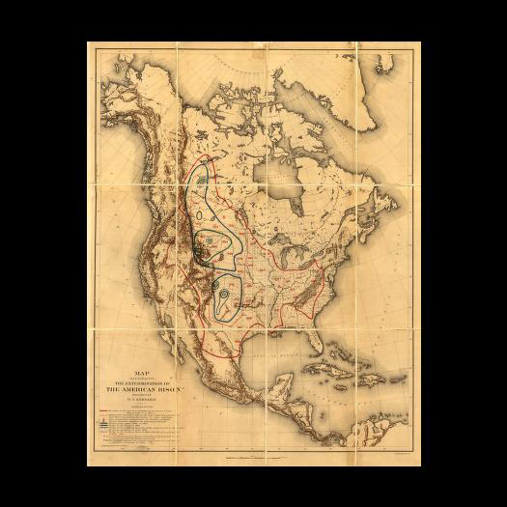
Historic bison range map from William T. Hornaday, The Extermination of the American Bison, 1889.

On August 15, 2007 the U.S. Fish & Wildlife Service issued a finding in response to a hand-written petition submitted by a citizen from Minnesota, Mr. James Horsley, on January 5, 1999, urging the U.S. government to protect the Yellowstone population - the last wild bison left in America - under the Endangered Species Act. The finding is online: http://a257.g.akamaitech.net/7/257/2422/01jan20071800/edocket.access.gpo.gov/2007/E7-16004.htm%00

Additional resources on the Endangered Species Act and Yellowstone bison are online: http://www.buffalofieldcampaign.org/legal/esamoreinformation.html

Buffalo Field Campaign’s Rebuttal to United States Fish & Wildlife Service Finding Not to list Yellowstone Bison as a National Endangered Species.

The U.S. Fish & Wildlife Service's finding does not consider how and by what migratory routes bison originally occupied the Yellowstone Plateau. This is a critical discussion - missing from their finding - regarding the native range of wild bison in the Greater Yellowstone ecosystem. Without this discussion, the American people and the international community have no way to independently judge whether bison are endangered “throughout all or a significant portion” of their native range as the Endangered Species Act requires of the fish and wildlife agency.

Dr. Mary Meagher, Yellowstone National Park's bison biologist for more than 30 years, believes that 10,000 years ago at the end of the last Ice Age, glacial retreat opened up range for bison migrating from surrounding river valleys who followed plant green up to the Yellowstone Plateau (Gates et al. 2005). Yellowstone's unique geothermal features opened winter range for bison to occupy habitat year round (Meagher 1973). Shortly after creation of the world's first national park in 1872, Yellowstone National Park became the last stronghold for the American bison, under armed guard to prevent the species extinction (Meagher 1973; Cope 1885).

Archeological investigations suggest large numbers of bison occupied the Greater Yellowstone region (Cannon 2001) and that habitat diversity and climatic regimes played an important role in bison distribution, seasonal migration and abundance (Cannon 1997; Williams 2005; Lyman and Wolverton 2002).

From Yellowstone National Park's gateway community in Gardiner to Livingston Montana, Yellowstone River Valley is one of several river valleys with documented bison jumps and other archaeological evidence of bison inhabiting range that the U.S. Fish & Wildlife Service did not consider as historic range in its finding:

"The Lamar Valley and the Yellowstone River Valley north of the park (Figure 4.1) to Livingston and beyond was an important area for bison and Native peoples throughout the Holocene. This system can be considered the original Northern Range for Yellowstone bison, functioning as an ecological continuum of grasslands that likely supported seasonal migrations by bison as far south as the high elevation ranges in the Upper Lamar Valley. Davis and Zeier (1978:224) described the lower Yellowstone Valley as an exceptional area for Native people to gather, drive and kill bison. Eight bison jumps and three kill sites have been documented south of Livingston. The closest jump site to YNP is 25 km north of the park boundary. It was used during the late prehistoric period between 1,700 and 200 b.p. (Cannon 1992). There is evidence of a human use corridor from the Gallatin and Madison River drainages into the interior Yellowstone National Park. Several major bison kill sites are located in the Gallatin Valley outside of Bozeman Montana." (Gates et al. 2005)

The U.S. Fish & Wildlife Service's finding fails to consider the biology and natural ecology of bison, their nomadic nature and migratory instinct, knowledge and memory of destination, and the evolutionary significant characteristics of a wild bison herd.

The American bison is a land-intensive species that once roamed over great distances (Boyd and Gates 2006). Long distance migration, what defines wild bison as a nomadic, herd animal that once thundered across the Great Plains, is in danger of being lost forever.

Berger (2004) examined the "ecological phenomena" of accentuated treks of native ungulates in the Yellowstone ecosystem and found that 100% of historic and current routes for bison have been lost.

Bison corridors and habitat on National Forest lands in the Madison, Gallatin and Yellowstone river valleys exist (Jourdonnais 2006; Lemke 1997; Lemke 2006) but the U.S. Forest Service does not manage habitat for wild bison despite its stated forest plan goal of providing "habitat for viable populations of all indigenous wildlife species..." (United States Department of Agriculture, Forest Service, Gallatin National Forest Land and Resource Management Plan, PAGE II-1, 1987).

For bison migrating onto Gallatin National Forest lands from Yellowstone National Park, the State of Montana's hunt, capture and slaughter regime awaits them (Bison Management Plan for the State of Montana and Yellowstone National Park 2000; Interagency Bison Management Plan 2000).

Migratory corridors and natural selection of habitat is critical to maintaining the Yellowstone bison herd's habitat and genetic fitness. These evolutionary significant attributes must be conserved for wild bison in their native range.

The U.S. Fish & Wildlife Service also fails to consider that wild bison as a native wildlife species are at risk of genomic extinction.

Circa 1500, American bison now occupy less than one percent of their historic range (Sanderson et al. 2008) estimated at 9,486,204 square kilometers / 3,662,643 square miles, or 948,620,400 hectares / 2,344,092,058 acres. Today, greater than 95% of the 500,000 bison in North America today reside in private commercial ownership (Boyd 2003). Less than 1.5% of bison are genetically Bison bison (Freese et al. 2007).

Forced cattle-bison breeding experiments to commercially exploit survival attributes of wild bison resulted in widespread introgression of cattle genes in private and public trust bison herds (Polziehn et al. 1995; Ward et al. 1999; Schnabel et al. 2000; Halbert 2003; Halbert and Derr 2007). Scientists do not know what harmful effects this may have on bison evolution. Nonetheless, the cattle genome displaces the bison genome and the offspring are considered a hybrid species.

Current genetic studies identified only 4 populations that can be genetically identified as Bison bison: Yellowstone National Park, Grand Teton National Park, Sully’s Hill National Game Preserve, and Wind Cave National Park (Halbert 2003; Halbert and Derr 2007).

The Sully’s Hill and Grand Teton herds were supplemented years ago with hybrid animals. Halbert (2003) and Halbert and Derr (2007) include conflicting information about potential cattle gene introgression in the Wind Cave herd which shares a fence line with Custer State Park bison, a hybrid herd.

In the United States, only one wild bison population has continuously occupied their native range since prehistoric time: the Yellowstone bison (Gates et al. 2005).

Loss of genetic diversity stemming from the near extinction of the species (Boyd and Gates 2006) coupled with extreme loss of historic bison range (Hornaday 1889; Boyd 2003; Sanderson et al. 2008) raises the risk of ecological extinction for wild bison (Freese et al. 2007).

The extensive prevalence of cattle genes in bison populations (Polziehn et al. 1995; Ward et al. 1999; Halbert 2003), habitat fragmentation, loss of natural habitats and isolated populations (Boyd 2003), limited range and population sizes, artificial selection, intensive management, unnatural confinement to fenced ranges, absence of predators, introduction of non-native disease (Freese et al. 2007) are some of the risk factors of ecological extinction that the U.S. Fish & Wildlife Service failed to consider in its finding.

Curtis Freese along with several scientists write: "Small herd size, artificial selection, cattle-gene introgression, and other factors threaten the diversity and integrity of the bison genome. In addition, the bison is for all practical purposes ecologically extinct across its former range, with multiple consequences for grassland biodiversity. Urgent measures are needed to conserve the wild bison genome and to restore the ecological role of bison in grassland ecosystems." (Freese et al. 2007)

"Today, the plains bison is for all practical purposes ecologically extinct within its original range." (Freese et al. 2007)

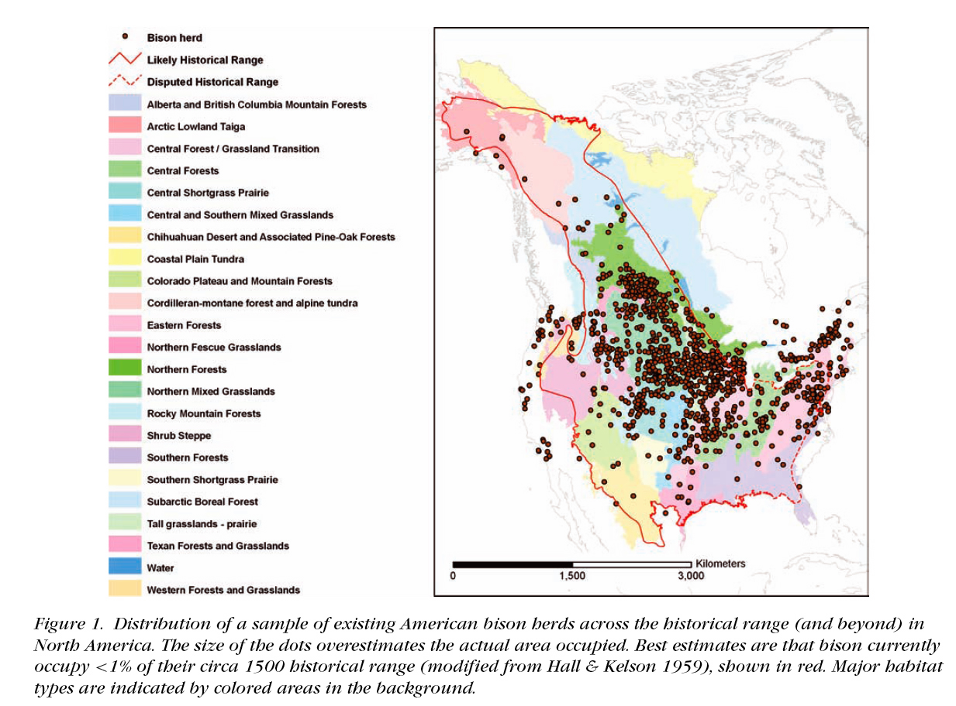

The U.S. Fish & Wildlife Service utterly failed to discuss the ecological importance of bison and the vital, keystone role they play in maintaining ecosystem health and function. The U.S. Congress had intended that the national Endangered Species Act protect not only endangered species but the ecosystem they reside in: "to provide a means whereby the ecosystems upon which endangered species and threatened species depend may be conserved." (http://www4.law.cornell.edu/uscode/html/uscode16/usc_sec_16_00001531----000-.html)
Extirpation of bison from their native range is an indicator that the prairie ecosystem they played a central role in forming is also at risk of extinction (Knapp et al. 1999).

"Knowledge of the bison's role in tallgrass prairies is lacking because the extent of this grassland and the abundance of its dominant ungulate have declined dramatically and in tandem over the last 150 years." (Knapp et al. 1999)

"Bison were a keystone species of the prairie ecosystem; significantly affecting the way the prairie grassland ecosystem evolved and playing an important role in maintaining it. Wild bison remain ecologically extinct in Montana. The State of Montana Department of Livestock has prevented the natural dispersal of wild bison into Montana from Yellowstone National Park because of disease issues while no attempts are underway to restore the species outside of this controversial region. Current management of private, state and Federal bison herds is leading towards domestication of bison that threatens their wild character and limits important natural selection processes." (Wildlife Society 2000)

Crucially, grazing by bison can reverse the loss of native grassland species and the disruption of grassland ecosystem structure and function caused by their extirpation (Collins et al. 1998).

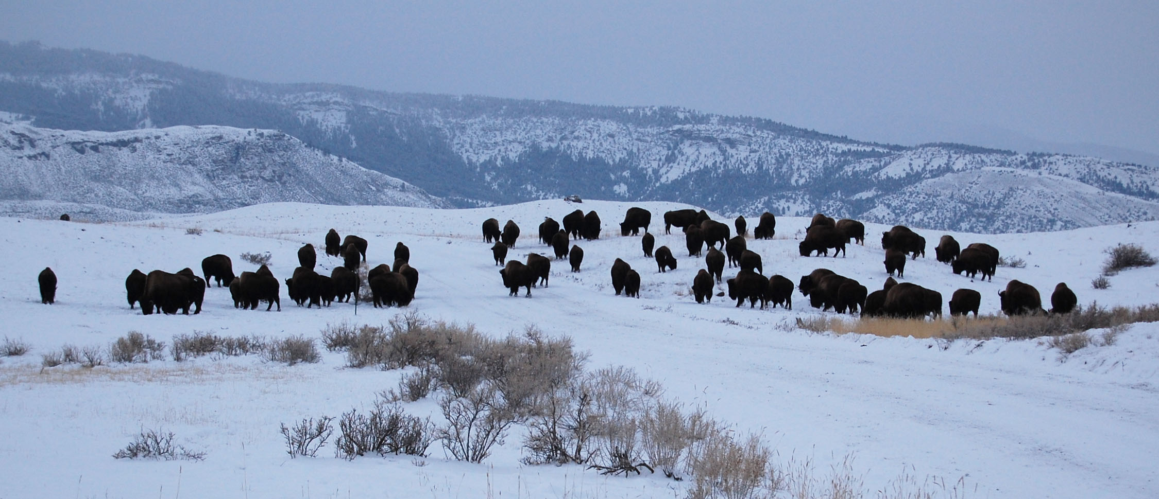
Bison group along Old Yellowstone Trail, Gardiner Basin, Montana, January 2008.

The U.S. Fish & Wildlife Service puts great faith in the "contingency measures" of the Interagency Bison Management Plan and its "successful management" to prevent the loss of the Yellowstone bison population.

The on-going slaughter of large numbers of wild bison by the state of Montana and U.S. National Park Service may threaten the genetic viability and integrity of the Yellowstone bison herd's population structure as revealed by several scientific studies (Halbert 2003; Christianson et al. 2005; Olexa and Gogan 2007; Gardipee 2007).

Scientists have identified distinct breeding grounds that help maintain genetic diversity within the Yellowstone bison herd (Gardipee 2007; Olexa and Gogan 2007). However, there is no evidence that the interagency plan has considered bison population structure in its management decisions and actions (Peter Gogan U.S. Geological Service pers. comm.).

"The current practice of culling bison without regard to possible subpopulation structure has potentially negative consequences of reduced genetic diversity and alteration of current genetic constitution both within individual subpopulations and the overall YNP [Yellowstone National Park] bison population." (Halbert 2003)

Loss of entire matrilineal bison groups, who have fidelity to natal sites and rutting territory, could alter and limit knowledge of destination and migratory routes retained for each bison population in Yellowstone.

"Since bison are known to naturally assemble in matriarchal groups including several generations of related females and the most recent calf crop (Seton 1937; Haines 1995), it is possible that the culling of bison at the YNP boundaries is non-random with respect to family groups, a practice that over sufficient time may lead to systematic loss of genetic variation." (Halbert 2003)

In a March 23, 2008 New York Times article, “Anger Over Culling of Yellowstone’s Bison,” Dr. James Derr, Texas A & M University, expressed concern that bison behaviors and traits including migration could be lost in the on-going bison slaughter. "The great-grandmother, grandmother, mother and daughter often travel together,” said Derr, adding that killing bison “is like going to a family reunion and killing off all of the Smiths.” This would affect “the genetic architecture of the herd,” Derr said.

Yellowstone National Park and the several federal and state agencies involved in executing the Interagency Bison Management Plan have not adapted to emerging science on Yellowstone bison herd dynamics, ecology and population structure (Peter Gogan U.S. Geological Service pers. comm.), raising the risk that irreversible genetic harm may have already occurred or is taking place within America's last herd of wild bison.

"… caution must be practiced in the management of populations with substructure to ensure the maintenance of both subpopulation and total population variation. The YNP bison population has not previously been managed with this consideration in mind. For example, 1,084 bison were removed from YNP in the winter of 1996-97, representing a 31.5% decrease in total population size. Even more troubling, however, is the inequality in the reductions across the Northern and Central herds. While the Northern herd suffered a loss of approximately 83.9% (726/825), the Central herd was reduced by only around 13.9% (358/2,571; Peter Gogan pers. comm.). If in fact the Yellowstone bison population is represented by 2 or 3 different subpopulations, disproportionate removals of bison from various subpopulations might have detrimental long-term genetic consequences." (Halbert 2003)

Wildlife Biologist D.J. Schubert wrote that at a May 21, 1998 meeting of the Greater Yellowstone Interagency Brucellosis Committee, Dr. Joe Templeton, Texas A&M University, summarized a bison genetics study on species surviving nearing extinction. Dr. Templeton reported, “every animal which is removed from the breeding population can no longer contribute to the genetic variability of the herd.” He cautioned the agencies that:

“The so called “random” shooting at the Montana’s borders is actually eliminating or depleting entire maternal lineages, therefore this action will cause an irreversible crippling of the gene pool. Continued removal of genetic lineages will change the genetic makeup of the herd, thus it will not represent the animals of 1910 or earlier.”

At the same meeting, Dr. James Derr, Texas A&M University, summarized a bison genetics study on genetic variation in extant and historical bison populations. Dr. Derr reported that the discovery, also reported by Dr. Templeton, of naturally occurring resistance to brucellosis might provide a viable long-term solution to the present bison controversy. He cautioned that “in order to fully explore this option (of a naturally occurring resistance to brucellosis) it is important to not reduce the bison population levels any further and risk the elimination of these disease resistant genes” and that “we should know the genetic makeup of bison before management decisions are made which may compromise the future of bison genetic health.”

AMERICAN BISON AS WORLD HERITAGE
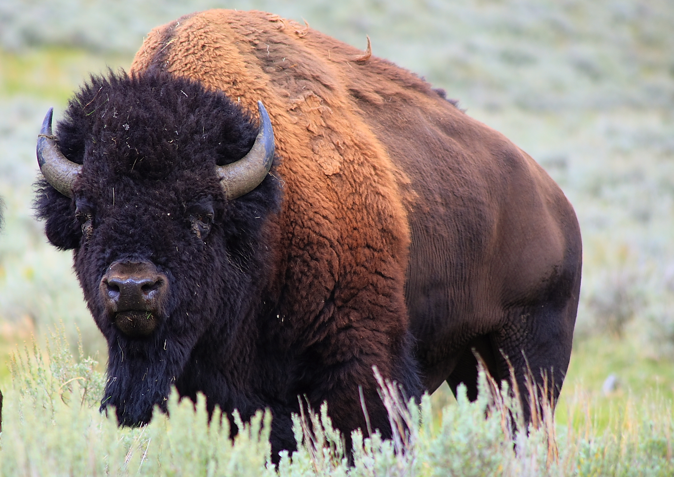
Yellowstone bison bull 2007. Seamus Allen photo

A copy of Buffalo Field Campaign’s report and briefing to the World Heritage Committee on Yellowstone bison is online: http://www.buffalofieldcampaign.org/worldheritage.html

On January 31, 2008 and April 5, 2008 Buffalo Field Campaign provided a report and briefing respectively to members of the World Heritage Committee, World Heritage Centre and The World Conservation Union to provide these members resources to fairly conduct a scientific review on the conservation status of American bison and the distinct population of wild bison to inhabit its native range in the present environment of Yellowstone National Park and the contiguous public and private lands adjoined to this World Heritage site: http://whc.unesco.org/en/list/28/documents/

The World Heritage Committee, World Heritage Centre and The World Conservation Union were asked to consider this presentation and critically apply its findings to the U.S. Department of Interior-National Park Service report on "the status of key conservation and management issues" for Yellowstone National Park and its examination by the Committee at its 32nd session July 2-10, 2008 in Quebec, Canada. An agenda is online: http://whc.unesco.org/en/events/449
Buffalo Field Campaign appealed to the World Heritage Committee to consider that this last remnant population of wild bison to continuously occupy their native range in the United States is an indigenous wildlife species of "outstanding universal value" at risk or in danger of extinction, and under threat of genetic harm and loss of diversity.

Yellowstone National Park was declared a Natural World Heritage Site in 1978 and listed as a World Heritage in Danger from 1995-2003. The United Nations Environment Programme and World Conservation Monitoring Centre have a report on Yellowstone National Park, excerpted below, and online: http://www.unep-wcmc.org/sites/wh/yellowst.html

KEY ha=hectare km=kilometer m=meter mm=millimeter °C=Celsius

YELLOWSTONE NATIONAL PARK, WYOMING, UNITED STATES OF AMERICA
Brief description: Yellowstone National Park, established in 1872, covers 9,000 square kilometres of a vast natural forest of the southern Rocky Mountains in the North American west. It boasts an impressive array of geothermal phenomena, with more than 3,000 geysers, lava formations, fumaroles, hot springs and waterfalls, lakes and canyons. It is equally known for its wildlife: grizzly bears, bison, wolves and wapiti, North American elk.

Threats to the Site: The Park was placed on the List of the World Heritage in Danger in 1995, because proposed adjacent mining for gold, silver and copper threatened the ecology and wildlife of the Yellowstone River. Ongoing contamination includes leaking sewage and waste, illegally introduced non-native lake trout which compete with the endemic Yellowstone cut-throat trout, road construction and year-round visitor pressures including the use of air-polluting snowmobiles in winter. Hundreds of bison were slaughtered in 1997 to eradicate brucellosis, a disease seen to endanger surrounding cattle. The authorities undertook to analyse thoroughly any measures taken to mitigate negative impacts.

The mine proposed in 1990 four kilometres from the northeast boundary would have stored toxic waste in the headwater area of major rivers. But in 1996 the President announced the removal of the threat through a US$65 million land-trade, which included clearing up local mine contamination. Other progress reported to the World Heritage Committee were the repair of sewer lines, the removal of exotic trout in 2001 and the planned control of brucellosis by the Interim Bison Management Plan of the Greater Yellowstone Brucellosis Committee which included state and federal agencies and local cattle ranchers concerned with the potential spread of the disease. As a result of these measures the World Heritage Committee took the Park off the list of endangered sites in 2003.
COUNTRY United States of America - Wyoming

NAME Yellowstone National Park

IUCN MANAGEMENT CATEGORY II (National Park) Biosphere Reserve
Natural World Heritage Site, inscribed in 1978. Natural Criteria i, ii, iii, iv Listed as World Heritage in Danger in 1995 because of proposed adjacent mining, pollution of rivers, year-round visitor pressure and road construction. De-listed in 2003.

BIOGEOGRAPHICAL PROVINCE Rocky Mountains (1.19.12)

GEOGRAPHICAL LOCATION In the southern third of the northern Rocky Mountains, in northwestern Wyoming state, with small adjacent areas of Montana to the north and Idaho to the west. The eastern boundary is largely topographically defined; other boundaries are largely geometric: 44°08' - 45°07'N, 109°10' - 111°10'W.

DATE AND HISTORY OF ESTABLISHMENT
1872: Designated by the U.S. Congress, as the world’s first National Park. Protection was provided by several congressional acts, initially under civilian then army administration;
1915: U.S. National Park Service (NPS) created and assumed management;
1976: The geothermal site was recognised as a Biosphere Reserve under the UNESCO MAB Program.

AREA 898,700ha: (Wyoming: 824,263ha, Montana: 61,144ha, Idaho: 12,743ha). The park is surrounded by the wilderness and wildlands of six national forests, two national wildlife refuges and Grand Teton National Park to the south. This Greater Yellowstone area is four times the size of the park itself and is considered the largest intact ecosystem in the temperate zone. Biosphere Reserve: 898,349ha.

LAND TENURE Federal government, except for 7.7ha. Administered by the National Park Service (NPS).

ALTITUDE Ranges from 1,610m to 3,462m. The plateau averages 2,500m.

PHYSICAL FEATURES The park lies in a caldera basin over a volcanic hot spot in the most seismically active region of the Rocky Mountains. Its central plateau is a 650,000ha forest surrounded by mountains that rise to 4,000m. Crustal uplifts 65 million years ago raised vast blocks of sedimentary rock to form the southern Rocky Mountains. For 25 million years andesitic volcanic ashflows and mudflows were common, covering and petrifying forests: nearly 200 species of petrified plants have been found. A more recent period of rhyolitic volcanism began in the region about two million years ago. During this time thousands of cubic kilometres of rhyolitic magma filled immense chambers under the plateau, then erupted to the surface. Three cycles of eruption, dated at 2.2 million, 1.2 million and 630,000 years ago, produced huge explosive outbursts of ash. The latest eruptive cycle formed a caldera 45km wide and 75km long when the active magma chambers erupted and collapsed, forming the Yellowstone plateau. The crystallising magma and injections of new magma are the source of heat for the hydrothermal geysers, hot springs, mud pots and fumaroles. Yellowstone contains more geysers than all the rest of the world with more than 300 in all, 200-250 being active, and more than 10,000 hydrothermal features.

Most of the area was glaciated during the Pleistocene, and many glacial features remain. The park lies on the headwaters of three major rivers: the Yellowstone River, a major tributary of the Missouri that flows via the Mississippi to the Gulf of Mexico, Firehole and Gibbon Rivers that unite to form the Madison River, which also joins the Missouri, and the Snake River that rises near the park's southern boundary and joins the Columbia to flow into the Pacific. Yellowstone Lake, 35,400ha in area, 2,357m high with a maximum known depth of 122m, is the largest high elevation lake in North America. Lower Yellowstone Falls, 94m high, is the highest of more than 40 named waterfalls in the park.

CLIMATE Precipitation ranges from 258mm on the northern boundary to an estimated 2050mm in the south-west corner, falling mainly as snow. Temperatures range from a January mean of -12°C to a July mean of 13°C at Mammoth.

VEGETATION Approximately 80% of the park is forested, and 80% of that is dominated by lodgepole pine Pinus contorta. 15% is grassland. Great elevational differences produce a range of plant communities, from semi-arid steppe to alpine tundra. Eight species of coniferous trees and about 1,700 species of vascular plants grow in the park. Two, Ross's bentgrass Agrostis rossiae and Yellowstone sand verbena Abronia ammophila, are endemic (NPS, in litt., 2002). The thermal areas contain unique assemblages of thermal algae and bacteria. However the National Parks Conservation Association reports that there are also some 200 invasive species.

FAUNA The Park has about 58 species of mammals. There are seven species of ungulates native to the Park: elk Cervus elaphus, mule deer Odocoileus hemionus, bison Bison bison, moose Alces alces shirasi, bighorn sheep Ovis canadensis, pronghorn deer Antilocapra americana, a population recently halved in number' and white-tailed deer Odocoileus virginianus. One non-native, mountain goat Oreamnos americanus may be colonizing the park (NPS in litt., 2003). Among carnivores a nationally threatened species, grizzly bear Ursus arctos is present. There are over 105 breeding females in the greater Yellowstone area, and 205 cubs have been born in the last three years. There are an estimated 280-610 grizzly bears in the Greater Yellowstone area. Black bear U. americanus is also abundant. Some 25-30 mountain lions Felis concolor occupy the Northern Range of the Park, others enter the Park seasonally. Lynx Lynx canadensis are found and coyote Canis latrans are numerous. The coyote population in the Northern Range has declined 30-50% since wolves were introduced. The grey wolf (Canis lupus (EN) was native, was extirpated by the 1930s but was reintroduced in 1994-5, with the aim of 30 wolf packs reproducing in three recovery areas (Yellowstone, Idaho, northwest Montana) for three successive years before de-listing of the species. This has succeeded. There are now 145 free-ranging wolves in 14 packs (NPS in litt., 2002).

A palaeotological study of Lamar Cave yielded the remains of over 30 mammal species. This suggests a diversity of fauna in prehistoric times much like that found in Yellowstone today. Elk were found in six out of nine levels above and below a layer radiocarbon dated at 960 years BP. Grey wolf bones were found below the 960 BP layer, and a wolf carnassial tooth even lower.

290 bird species have been recorded, 148 breeding in the Park. Of special interest are the whooping crane Grus americana (EN), the nationally threatened bald eagle Haliaeetus leucocephalus, peregrine falcon Falco peregrinus, and trumpeter swan Cygnus buccinator. There are 13 native fish species. Yellowstone cut-throat trout Oncorhyncus clarki bouvieri and Arctic grayling Thymallus arcticus (V), are protected by regulations that also permit taking of non-native introduced species. Six exotic species of fish have been introduced, including brook trout Salvelinus fontinalis, lake trout S. namycush, brown trout Salmo trutta, rainbow trout Oncorhyncus mykiss and lakechub Couecius plumbeus (NPS pers.comm.1995). There are also 6 reptile and 4 amphibian species.

CULTURAL HERITAGE The Park's cultural history dates back 12,000 years. It includes prehistoric and historic use by a variety of American Indian groups who relied heavily on the resources of the area, exploration by trappers and adventurers and use by contemporary American Indians, some resident up to the time of the Park's designation. About 2% of the park has been inventoried for archaeological resources, and some 575 prehistoric and historic archaeological sites have been recorded of which approximately 84% are American Indian (NPS pers. comm., 1995). Yellowstone has over 1,000 historic structures associated with the Euroamerican occupation and management of the park where the legacy of the early civilian and army administration and the history of concessions in national parks are preserved (NPS, pers. comm., 1995). Six of these structures are National Historic Landmarks: Fishing Bridge Trailside Museum, Madison Junction Trailside Museum, Norris Geyser Basin Trailside Museum, Northeast Entrance Station, Obsidian Cliff and Old Faithful Inn. There are four National Historic Districts: Lake Fish Hatchery, Mammoth Hot Springs, Old Faithful and Roosevelt Lodge. And there are five National Historic Sites: Lake Hotel, Lamar Buffalo Ranch, Obsidian Cliff Kiosk, Queen's Laundry Bath House and the U.S. Post Office at Mammoth Hot Springs. The Park's collections have some 200,000 natural and cultural objects including artwork, ethnographic and archaeological artifacts, historic objects, and natural resource specimens (NPS, pers. comm. 1995; NPS, in litt., 2002).

CONSERVATION VALUE Yellowstone provides a clear record of volcanic eruptions which have occurred over the past 55 million years and contains over 10,000 hydrothermal features, including fumaroles, mudpots, hot springs and over 300 geysers. The park is also a reservoir of genetic diversity and contains a natural forest ecosystem vast enough for the perpetuation of grizzly bear, wolf, bison and wapiti populations.

CONSERVATION MANAGEMENT Historically, Yellowstone has been managed both for the preservation of its resources in their natural condition and as the 'pleasuring ground' for tourists that it was also created to be. Wolves, mountain lions and coyotes were seen as threats both to the park's ungulates and to safe tourism, and from 1915 onwards were eradicated in an efficient predator control program. This led to overpopulation and disease amongst ungulates, necessitating large scale culls which caused controversy. Later, the desire to re-establish a more natural ecological balance has led to the reintroduction of some species formerly eliminated. Today there are three defined management zones: natural, 897,656ha; historic, 32ha; and development, 810ha. A master plan (1973), land protection plan (1986), an exotic vegetation management plan (1986) statement for management (1991), and a natural resources management plan (1995), are among the documents that guide conservation of park resources. A fire management plan was adopted in 1972, expanded in 1976 and revised in 1986. Following the major fire in 1988 it was revised again in 1990, 1992 and after the 1994 fire season again in 1995 (NPS, in litt., 2002).

Grizzly bears have been the subject of intensive study and management for more than 35 years. Their recovery has been of highest priority in the greater Yellowstone ecosystem since the species was listed as threatened in 1975, under the Endangered Species Act. This promoted an unprecedented level of interagency cooperation, and public controversy. Interagency Grizzly Bear Guidelines (1986) and a 1993 Grizzly Bear Recovery Plan are followed for their management. Cooperative interagency teams also direct the research into, monitoring and management of ungulates, mountain lions, coyotes, peregrine falcons, bald eagles and trumpeter swans with many other species and resources in the greater Yellowstone area. Hunting, logging, mining, and domestic livestock grazing are prohibited. Regulated fishing and camping are allowed.

MANAGEMENT CONSTRAINTS Although a very large area, Yellowstone is ecologically an island which is subject to the fragmentation of its habitats and is surrounded by livestock raising and mining claims which have made the protection of a buffer area of a Greater Yellowstone ecosystem controversial. This applies especially to its population of bison which are the only wild continuously free-ranging bison in the United States, numbering about 3,500 in the winter of 1996-7 and have enormous national symbolic value. Winter weather naturally regulates their numbers in the Park, but snow-ploughing of park roads for snowmobiles facilitates their movement and their recolonising of lands outside the park. This has led to the perceived need for an annual cull north and west of the park during which thousands of bison have been killed by the US Department of Agriculture and the Montana Department of Livestock since 1985. This not only keeps their numbers in check, but is held to reduce the spread of brucellosis a disease which some of the Yellowstone bison population harbors and is said to cause brucellosis, causing cows them to abort their calves, and threatening the interstate shipment of cattle.

In 1995 the State of Montana sued the NPS and USDA Animal and Plant Health Inspection Service for delaying their long-term bison management planning and during winter of 1996-7 its agents shot and shipped to slaughter 1,500 bison in a brucellosis control campaign which became a nationally important public issue. After long negotiations, the federal agencies developed and in 2000, persuaded the State of Montana to adopt its final environmental impact statement on bison management designed to reconcile the free-ranging population with protection of Montana's livestock industry from the threat of disease. Measures include monitoring the population, permitting bison to range some of the public lands adjoining the Park in winter when there are no cattle present, and eventually vaccination (NPS, in litt., 2002).

The winter range of the northern Yellowstone elk herd has been under study since the 1920s. Past winter feeding by the management in the past increased numbers which then required control. To deal with overpopulation and overgrazing, elk were translocated to restock other ranges and numbers were reduced by ranger shootings until 1968. Since then, the National Park Service, U.S. Forest Service, and Montana Department of Fish, Wildlife and Parks have experimented with natural regulation, coupled with continuous monitoring, range studies, and hunting outside the park. Five of the seven elk herds are migratory which exposes them to conditions outside the Park's boundaries such as the carrying by some elk in both Wyoming and Idaho of brucellosis.

The isolated pronghorn population may also be threatened by commercial development and subdivision of private lands north of the park. Rainbow and brown trout have replaced cut-throat trout and grayling in much of the Madison River. Predatory lake and brown trout have severely affected the Snake River fine-spotted cut-throat. Lake trout were apparently illegally stocked in Yellowstone Lake some time before 1994 and threaten the native cutthroat trout and piscivorous species and ecosystem that depend on them - grizzly bears, bald eagles and several other species of mammals and birds. Some progress has been made by an intensive campaign since 1995 to eradicate lake trout - 43,000 were removed in 2001 (UNESCO, 2002), but it will need constant work. Another threat is invasion by the whitebark pine blister rust which destroys a source of grizzly bear fodder.

Among other threats, 248 fire starts were recorded in the greater Yellowstone area in 1988. A let-burn policy towards naturally started fires allowed 31 to burn as prescribed fires, covering 157,480ha. Of five large fires originating outside the park, three, including the largest of all (the North Fork Fire, 201,610ha) were man-made. They were fought from the start, but still destroyed 36% (321,520ha) of the area within the Park. Surface mining, oil, gas and geothermal exploration and extraction near park boundaries, leakage from sewer lines, contamination by wastes, by road construction and maintenance and the year-round pressure of visitors all potentially threaten the park's air and water quality, visual integrity and critical habitat for wildlife. One example is the intrusion, sanctioned by the federal government in mid-2002, of individual snowmobiles which may total 75,000 and introduce fumes and noise into the winter wilderness. This was done in the face of a previous Park Service ban, the findings of a major study, wide public opposition to snowmobile use and the Park authority's advocacy of less polluting snow-coaches (NPCA, 2002).

A major challenge was the proposed New World mine 4.2km from the northeast corner of the park in the headwaters of three streams. Toxic waste from this would have threatened the Park's streams and affected grizzly bears, bald eagles, bighorn sheep, elk, fish and many smaller animals (Anon., 1995; National Parks, July 1995, 1997). Such plans to exploit its resources led to Yellowstone being placed on the list of World Heritage in Danger in 1995 (UNESCO, 1996), an action questioned by defenders of national sovereignty over property rights in the U.S. (Rabkin, 1997). In 1998 the government compensated the company with $65 million for divesting its interest in the gold mine site (UNESCO, 1999). A moratorium has also since been placed on mining around Yellowstone to prevent the expansion of existing mines. However, pollution from abandoned tailings will have to be warded off in permanently. A proposed nuclear waste incinerator in Idaho, is also seen by conservationists as a potential threat to its air quality (NPS, 2001).



